Diversity and Inclusion:
Annual Report 2017-2018
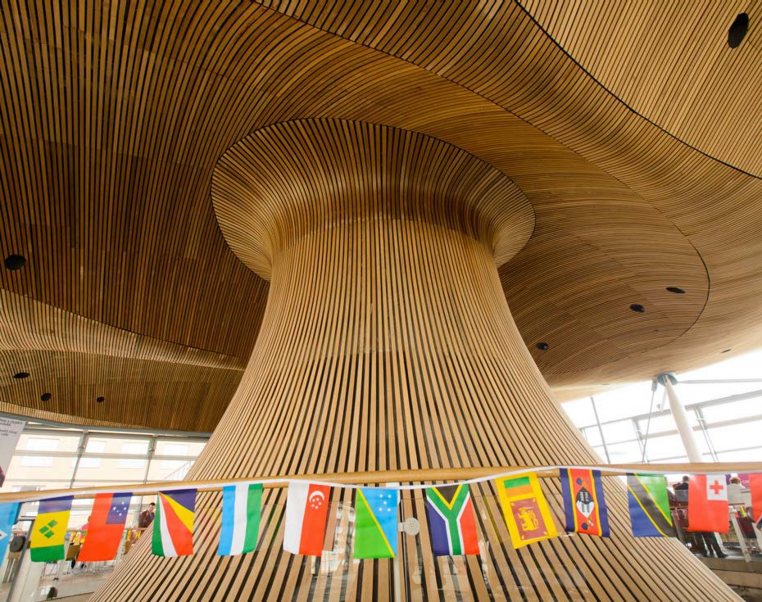
July 2018

The National Assembly for Wales is the democratically elected body that represents the interests of Wales and its people, makes laws for Wales, agrees Welsh taxes and holds the Welsh Government to account.

An electronic copy of this document can be found on the National Assembly website: www.assembly.wales

Copies of this document can also be obtained in accessible formats including Braille, large print, audio or hard copy from:

National Assembly for Wales Cardiff Bay

CF99 1NA
Tel: 0300 200 6565
Email: Contact@assembly.wales
Twitter: @AssemblyWales

© National Assembly for Wales Commission Copyright 2018
The text of this document may be reproduced free of charge in any format or medium providing that it is reproduced accurately and not used in a misleading or derogatory context. The material must be acknowledged as copyright of the National Assembly for Wales Commission and the title of the document specified.

Diversity and Inclusion:
Annual Report 2017-2018
July 2018

Contents
Foreword 6
Our year in highlights 8
Our Diversity and Inclusion goals 10
Our People 12
Outreach, engagement and democratic participation 28
Diversity and Inclusion in our work 44
What next? 48
Annex A: Monitoring Information 50
Annex B: Equal Pay Audit and Gender Pay Gap Reporting 2018 95

Foreword

This report provides an update on activities related to diversity and inclusion over the period from 1 April 2017 to 31 March 2018.

We are delighted that the Assembly Commission continues to have diversity and inclusion at the very heart of everything that we do as a parliament, as an employer and as a service provider to the public that we represent.

This annual report includes some of the highlights of the year. Whilst it does not and could not capture everything that we do, it provides an insight into our approach.

We are very grateful to our staff for the work they do to help us to be an inclusive organisation. We know that our staff are our best asset and we want to make sure that they work in a supportive and safe environment.

We are not complacent. We still have a lot of work to do – ensuring that our workforce represents the community that we serve is one of our priorities.
However, it is important to recognise how far we have travelled and to celebrate the successes to date.

As ever, we welcome your feedback on this report and on our approach to embedding diversity and inclusion.

Manon Antoniazzi
Chief Executive and Clerk to the Assembly.

Joyce Watson AM
Assembly Commissioner with responsibility for employees and equalities

Our year in highlights

We were named by Stonewall as the top employer in the
UK for LGBT people. We were identified as a “trailblazer” by Stonewall, and named the Top Trans-inclusive employer, and our workplace network was highly commended for their activity In the accompanying survey, 91% of our non-LGBT staff agreed that they consider themselves to be an advocate for LGBT equality.

Over 15,000 people from across Wales’ diverse communities have had their say in the work of Assembly committees through surveys and online forums during this period.

We undertook more work to ensure that we protect people’s dignity when working at the Assembly or engaging with people
that work here.

Our qualified teachers and youth workers have continued to engage with children and young people to develop democratic awareness and to promote the forthcoming youth parliament. During this reporting period, 21,135 young people have engaged with us during arranged educational sessions.

We have undertaken a review of our recruitment practices to ensure that they are inclusive.

We have reached out to communities across Wales to encourage democratic participation and to promote the Assembly as an employer of choice, including at Pride Cymru, at a suite of events for Black History Month, and celebrating women in politics by marking the centenary of some women getting the right to vote.

We reshaped our apprenticeship scheme to increase external outreach and make the scheme more inclusive resulting in more diverse applications than ever before.

Our committees have covered a range of diversity and inclusion topics including refugees, children’s rights, perinatal mental health, and equalities and Brexit.

Following the launch of our Mental Health policy, we launched MINDFUL, our mental health and wellbeing workplace equality network. Throughout the year, the network has worked extensively with external partners to promote mental health and wellbeing and reduce stigma.

We celebrated the cultural diversity of people who work at the Assembly with a recipe book of traditional dishes from across the world.

Our Diversity and Inclusion goals

Our Vision and Values

It is important that the Assembly continues to be accessible to the people of Wales and beyond: making it relevant, easy and meaningful for people to interact with and contribute to its work. It is also important that we are an inclusive employer, enabling all of our staff to realise their full potential.
We want to continue to be an exemplar organisation in valuing diversity, promoting inclusion and embedding equality, both as an employer and as a parliamentary organisation. Our vision is to be an organisation that is accessible and engages with and respects the people of Wales.
Our values define the way we work. We:
- ensure diversity and inclusion are embedded throughout everything we do;
- challenge and strive to eliminate harassment and discrimination;
- recognise and address barriers to inclusion, access and participation;
- behave as an inclusive employer and accessible parliamentary organisation;
- aim for our workforce to be representative of our diverse society, including at a senior level;
- encourage and widen participation in Assembly activities and engagement with the Assembly from people across Wales; and
- promote positive attitudes towards diversity and inclusion and foster good relations between different groups of people.

Our Priorities
Our Diversity and Inclusion Strategy 2016-21 sets out the following priorities and objectives.
- Fostering inclusive leadership and an inclusive workplace culture. We will deliver against this objective by ensuring senior accountability and inclusive leadership, and by supporting and developing our Workplace Equality Networks
- Building on our approach to organisational development. We will deliver against this objective by identifying and removing barriers to inclusion, through external benchmarking and recognition, learning and development, and inclusive workplace policies
- Supporting Assembly Members and their staff to build diversity into their work. We will deliver against this objective by supporting them to consider diversity and inclusion into their roles as employers, as service providers and into their work as caseworkers, scrutineers and legislators, and by engaging with the people of Wales.
- Supporting Assembly Commission staff to build diversity and inclusion into their work. We will deliver against this objective by ensuring inclusive decision-making, service design and delivery, and by taking into account diversity and inclusion when buying-in goods and services.
- Being an Inclusive Employer which attracts and retains the widest pool of talent where all staff have the opportunity to realise their full potential. We will deliver against this objective by supporting our talented workforce, recognising and addressing underrepresentation in our workforce, and collecting and using diversity data to identify and address any inequalities.

Our People

At the Assembly Commission, we always strive to be an inclusive employer. We want to be an employer of choice where people outside of our organisation want to work here and for the Assembly to be a desirable and attractive place to work. We want to be an exemplar employer, and a place where people can thrive in a safe and supported environment.

Creating an inclusive working environment
- 31 days annual leave per year
- Incremental pay rise
- 13 days Public and Privilege
holidays per year
- Principal Civil Service pension
scheme
- Access to occupational health

- Access to Employee Assistance
Programme
Family friendly policies, including career break, part-time working, job share, term time working and
special leave
- Supportive work place equality
networks
- Generous maternity, foster, adoption, and shared parental
leave

Staff survey 2017

We had a great response to our latest staff survey with positive results around diversity and inclusion. 82% of staff responded to our staff survey, with an engagement score of 74%. 81% of respondents said that they are treated with respect by the people that they work with, 77% said that the Assembly Commission respects individual differences, and 79% feel valued and respected for who they are.
Although we had a large number of responses, the low declaration rates for equality monitoring mean that it is difficult to draw any firm conclusions or to identify any trends. We will continue to encourage people to complete the equality monitoring form as part of the staff survey to ensure that we can have a more complete picture of the feedback from all of our workforce.
Workforce and recruitment statistics

Our workforce and recruitment data is published in Annex A. It shows that we continue to attract and recruit a diverse range of people. We have recruited people from a range of ages, with disabilities, and from different races, religions and sexual orientations. We have recruited similar numbers of women and men (21 and 24 respectively) but we have not recruited anyone with a different gender identity or anyone who identifies as transgender.
Internally, although we have had a relatively small number of internal job opportunities (28 opportunities) we have had successful candidates from a Black, Asian and Minority Ethnic (BAME) background, with disabilities, across different age groups and sexual orientations. The data shows that women are twice as likely to be offered a job internally as men.
We recognise the need to continue to work on increasing the diversity of our workforce in order to better represent the communities that we serve. Our review of recruitment has enabled us to identify further opportunities for reducing barriers and encouraging a diverse range of applicants.
House of Commons Speaker’s BAME Challenge

Our Diversity Team and Race, Ethnicity and Cultural Heritage network were invited to participate in the Speaker’s Black, Asian and Minority Ethnic (BAME) challenge. The objective of the challenge was to refocus the energy and commitment of UK employers on improving the way they attract, recruit and develop BAME employees. Three Action Groups were formed representing the expertise of over

50 different organisations. The groups met over 12 months to develop a practical on-line toolkit which draws on best practice from across all sectors, that provides solutions to BAME inclusion that can be used by organisation of all types and sizes. The toolkit will be launched in the summer of 2018.
Recruitment review

To ensure that our policies and practices are inclusive and continue to represent best practice, we have undertaken an external review of our recruitment processes. Recognising that there is currently lots of work being done to create and maintain an inclusive environment, the review makes a number of recommendations to help us fine tune our recruitment practices further. These are being taken forward by our recruitment team and we will report on progress in the next annual report.
Learning and Development

This year, we have continued to increase our diversity training offer and we have reviewed the content of our training to make sure that the language and terminology used are inclusive. There is a range of formal and informal training opportunities available to Assembly Commission staff and Assembly Members and their staff.
During this period, we have provided a range of training including autism awareness, supporting LGBT staff, coaching and mentoring, dementia awareness, non-binary gender identities, disability confidence, unconscious bias, managing stress, mental health awareness for line managers, British Sign Language, challenging inappropriate behaviour, supporting vulnerable constituents, supporting colleagues with autism, emotional intelligence and personal resilience. We also provide a suite of factsheets, videos, online training and other resources to those who are unable to attend the training or who wish to develop their knowledge in their own time.

Our Welsh language skills team undertook some training on Dyslexia to help them adapt their teaching methods and recognise when learners may need additional support. We purchased some specialist teaching resources following the training to ensure that we have everything in place to assist learners with dyslexia.

Diversity and Inclusion Week: 3 -7 July 2017

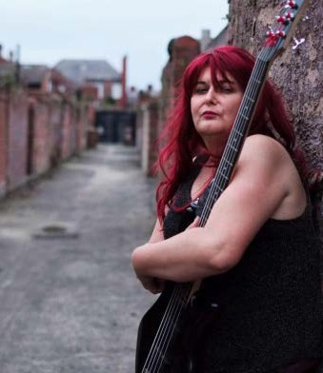
Our annual Diversity and Inclusion Week was once again a great success, with a mixture of internal awareness raising, events, and an external social media campaign. Our events included a Q&A session with the Chief Executive and senior equality champions, diversity
and inclusion training for managers, unconscious bias training, dementia awareness and a fascinating presentation on trans identities and gender
expression in rock music. Our internal and external blog articles covered a variety of topics including challenging inappropriate behaviour, supporting a cross-generational workforce, promoting the Assembly as an inclusive employer, the role of men in fighting for gender equality, and domestic violence as a workplace issue.
Promoting inclusion through internal awareness raising

Throughout the year, our Diversity and Inclusion team and workplace networks have continued to raise awareness of issues for our staff, Assembly Members, their staff and
the public. Highlights this year include mental health awareness, staff network day, trans day of remembrance,
holocaust memorial day, autism awareness, LGBT History Month, International Day of Disabled People, awareness of domestic abuse, Alzheimer’s awareness, autism hour, human rights
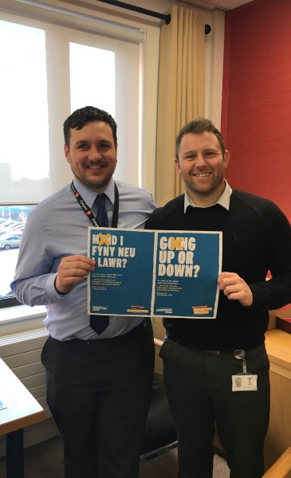
day, Black History Month, and International Women’s Day.

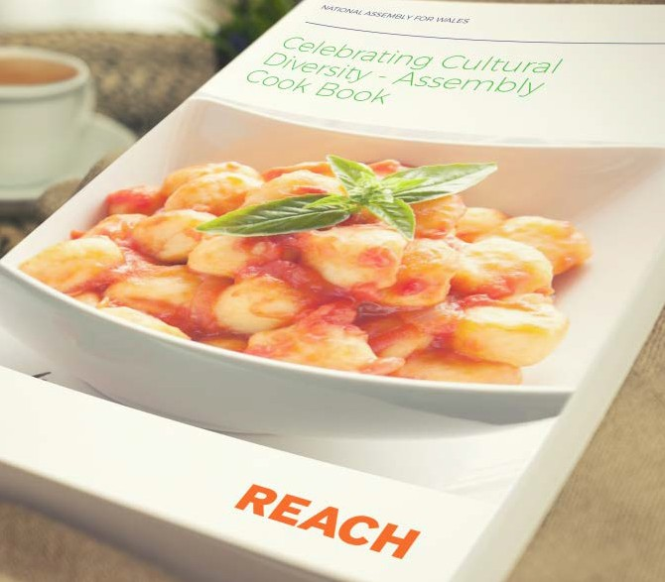

Celebrating Cultural Diversity

To showcase the cultural diversity of people who work at the Assembly, our Diversity Team and Race, Ethnicity and Cultural Heritage (REACH) network produced a recipe book of dishes from across the world.

We asked people to share either a family favourite or a recipe that they felt epitomised their heritage. The recipes we collated came from many different places including Israel, Nigeria, Lithuania, Italy, Wales, Scotland, Gibraltar, Angola, Malaysia, Somaliland, Pakistan, Algeria, Greece, South Africa, England, Ireland, Lithuania, Poland and Granada.

Some of the dishes were prepared in our canteen for staff to enjoy as part of Black History Month. Not only did the recipe book provide some great ideas for meals and snacks, but it also allowed us to find out some more about our colleagues, their background and cultural heritage.

Workplace Equality Networks

Our Workplace Equality Networks help us to promote diversity and to consider inclusion in our work. They provide peer support for members and allies and take forward campaigns to promote inclusion. During this year, we ensured that each network has a senior champion to provide senior representation and sponsorship at Leadership Team, and we celebrated the value of our networks by marking the inaugural National Day of Staff Networks in May 2017.

MINDFUL
Ein Rhwydwaith Cefnogi Iechyd Meddwl
Our Mental Health Support Network
INSPIRE
Ein Rhwydwaith Menywod
Our Women’s Network

EMBRACE
Ein Rhwydwaith Anabledd
Our Disability Network
OUT-NAW
Ein Rhwydwaith LGBTQ+
Our LGBTQ+ Network

TEULU
Ein Rhwydwaith Gofalwyr a Rhieni sy’n Gweithio
Our Working Parent and Carer Network
REACH
Ein Rhwydwaith Hil, Ethnigrwydd a Threftadaeth Ddiwylliannol
Our Race, Ethnicity and Cultural Heritage Network

Mindful

We were also very pleased to launch our sixth network, MINDFUL, our Mental Health and Wellbeing network. This network is open to everyone who works on our estate who has been affected by mental health. Having a mental health workplace network and a senior champion gives us a great platform from which to highlight and progress the support that’s available to staff, based upon their needs and experiences.
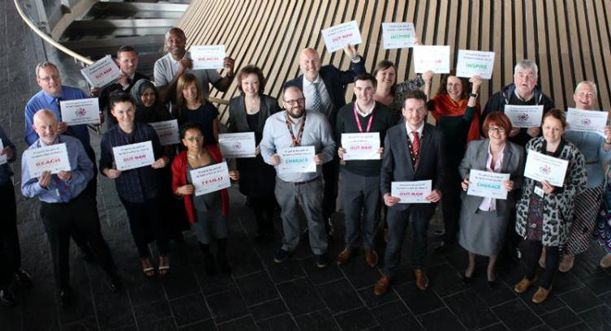
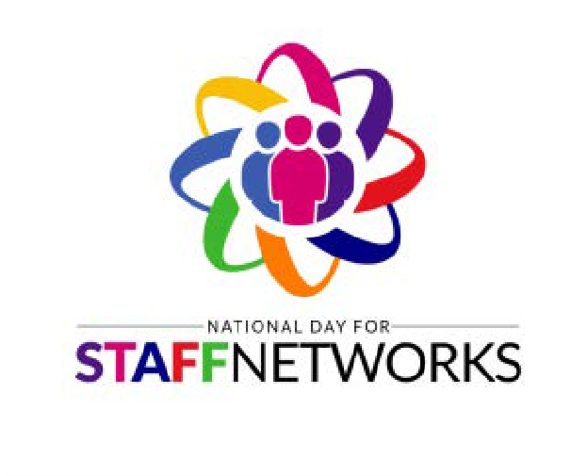

MINDFUL
Ein Rhwydwaith Cefnogi Iechyd Meddwl
Our Mental Health Support Network

Photos
Top: Assembly network members, allies and senior champions mark National Day of Staff Networks.
Bottom left: Logo for Mindful network
Bottom right: Logo for National Day of Staff Networks

Our senior champion for MINDFUL said:

The Assembly has taken a welcome step in identifying a member of the senior leadership team as a champion for mental health, signing the Time to Change Wales pledge and supporting the Mindful staff network. My role means making sure that the mental health of those in the organisation is a priority and that our services and support are focussed and joined up. I enjoy working with the network who have an enthusiastic core of members who are keen to make sure that our policies work and that there is no stigma attached to talking about mental health. They
are passionate about supporting other staff and hold regular events to promote support and provide a space for people to talk.

Mental health and our security team
Members of our security team have received mental health training to raise awareness of supporting people with different conditions and to help challenge the stigma around mental health.

A member of the security team was involved in the development of our mental health policy and subsequently
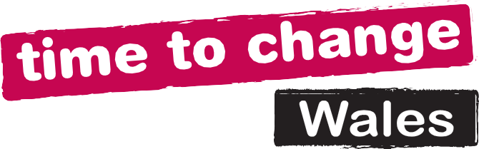
volunteered to Co-Chair our new mental health network. Also the head of security filmed an interview to discuss their
experience of how they supported a member of the team during a period of mental ill health. This video was shared with all staff as part of our work to mark Time to Talk Day, aimed at removing the stigma around mental health.

Faith visits

The Diversity and Inclusion team, in conjunction with the Race Ethnicity and Cultural Heritage (REACH) network and South Wales Police, offered Assembly Members, their support staff and Commission staff the opportunity to gain a greater understanding of Islam, Hinduism, Sikhism and Orthodox Judaism, by visiting four places of worship. The Co-Chair of REACH said: “A really worthwhile experience and a great learning opportunity. Not only did I come away understanding more about the different faiths but more importantly I learnt that there were many similarities within all the religions, like not judging people, doing charitable acts, etc. The fact that there is some commonality to be found even in the face of such diverse beliefs is reassuring.”
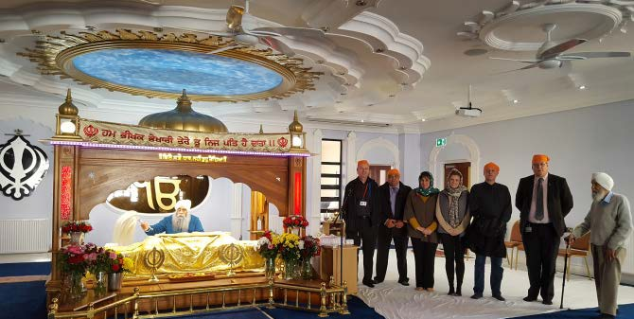
Purple Light up campaign To mark International Day of
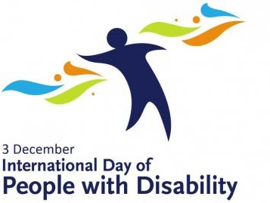
Disabled People on 3 December, EMBRACE, our disability network organised for the Senedd to be illuminated in celebration of
the enormous contribution that people with disabilities make to Wales’ and the world’s economy
- as part of the Purple Light Up campaign.

BAME Leadership Development Programme

Two members of our Race, Ethnicity and Cultural Heritage (REACH) network attended BAME leadership development training through our membership of the Welsh Black, Asian, Minority Ethnic Public Sector Network. The course helped attendees to understand their leadership strengths, effective leadership techniques and personal empowerment. One of our attendees said “it was a great opportunity for me to learn valuable leadership techniques and develop the confidence to use them.”
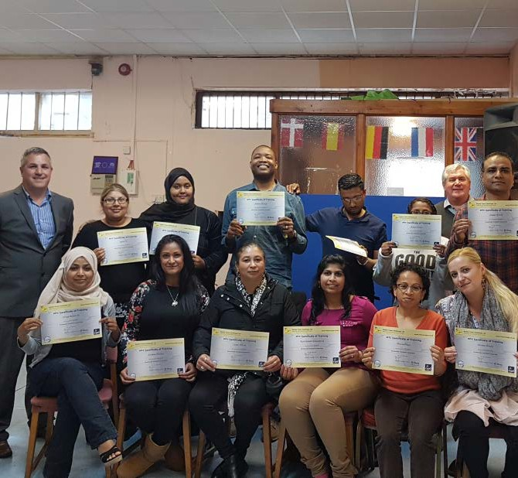

Photos
Left page: Assembly staff join a tour of the Sri Dasmesh Singh Sabha Gurdwara Bhatra Sikh Centre.
Right page: Attendees at the BME Leadership development training.

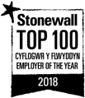
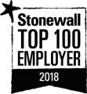
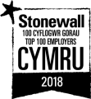
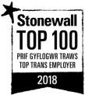
Diversity and Inclusion: Annual Report 2017-2018

Benchmarking and external recognition

A useful measure of our approach to diversity and inclusion is to benchmark again external organisations and to undertake accreditation exercises. These enable us to identify where we are exhibiting best practice and where we can make further improvements.
This year we achieved the following:
  - We are currently ranked first in the UK in Stonewall’s 2018 Workplace Equality Index. In addition, we have been named the Top Public Sector Employer in Wales for the last five years, a top trans employer and our LGBT staff network has been highly commended. We have also been named by Stonewall as a Star Performer organisation due to our consistency at the top of the Index. Since achieving this ranking we have had a great deal of media coverage and have shared best practice with a myriad of organisations. The Llywydd has stated “We are truly honoured to be recognised as the leading employer in the UK for lesbian, gay, bisexual and transgender people. The National Assembly has diversity and inclusion at the very heart of its role representing the people of Wales.”

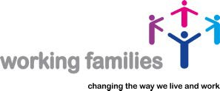
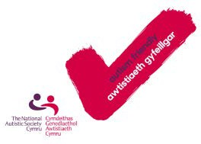
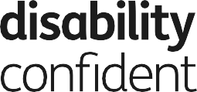
Diversity and Inclusion: Annual Report 2017-2018

  - We have been recognised as a Disability Confident employer by the Department for Work and Pensions. This status ensures that we are complying with best practice around the recruitment and retention of disabled people.
  - We are committed to providing a family-friendly working environment and have been named as a top employer for working families, accredited by the Top Employers for Working Families organisation, an industry-recognised bench marker for good practice when it comes to providing a working environment that allows for a positive work / life balance.
  - We have been awarded the National Autism Society Autism Friendly Award. This recognition shows our commitment to making sure that our buildings are accessible to visitors with autism and that our staff have been trained to welcome them.
  - We have signed up to the Citizens Cymru Wales Community Jobs Compact, a scheme that aims to bring local people and employers together to tackle poverty, unemployment and under-representation in the workforce. The Compact encourages employers to commit to best practice in relation to pay, equal opportunities, job security and development.

We have also previously gained the following recognition:
  - We have received the Investors in People Gold Standard, recognition from the international mark of global excellence.
  - We have achieved the Action on Hearing Loss Louder Than Words charter mark for supporting staff and visitors who are deaf or have a hearing loss. We have also been awarded Excellent Wales awards by Action for Hearing Loss Cymru for service excellence.
  - We have been recognised as one of The Times / Opportunity Now Top 50 Employers for Women.
Equality and Access Fund – support for AMs, their staff and their constituents

The Equality and Access Fund enables Assembly Members to cover the cost of additional expenses such communication support and reasonable adjustments. During this reporting period, the fund has been used to improve access to constituency office, provide information in alternative formats, sign language interpretation and specific ICT equipment for Members and their staff.
Work experience placements

Over the course of this year, we have provided work experience opportunities to many people including work shadowing experiences for participants of Oxfam Skills for Life project, which helps women gain the skills and confidence needed to progress into work, with a particular focus on Black, Asian and Minority Ethnic (BAME) women. We have also provided opportunities for students from Cardiff University and young LGBT people from Stonewall’s work experience scheme.
These experiences introduce people to the world of work and to the Assembly as an inclusive organisation and a welcoming place to work.

Apprenticeship scheme launch – March 2018

Our apprenticeship scheme is designed to encourage people from all backgrounds to work with us. The scheme offers a training programme where apprentices learn specific job skills, gain a qualification, and obtain valuable experiences from coaches and mentors to help them to fulfil their potential. This year, we re-shaped the apprenticeship programme and introduced new initiatives to engage with the people from a Black, Asian and Minority Ethnic (BAME) background as this group has been consistently under-represented in our workforce. We have made changes to make the process more inclusive. We:
  - Produced a new simplified application form;
  - Introduced a blind sift and provide unconscious bias training for all panel members and assessors;
  - Replaced competency based questions with a values based approach so not to deter those with limited or no work experience;
  - Built better relationships with schools and partners in the community such as Citizens Cymru;
  - Designed a new website, and re-branding content to better engage with potential applicants; and
  - Increased our engagement work by conducting workshops, offering drop-ins and attending career fair.
Over 190 people took part in 11 outreach sessions. Groups who participated included Maindee Youth Project, Butetown Community Centre, EYST Swansea, the All Wales BAME Engagement Programme, SOVA Ace Wrexham, and the Oxfam Skills for Life Project. The application window closed in April 2018 and we will report on the demographic composition of applicants in the next annual report.

Dignity and Respect in the Assembly

We are committed to providing a safe place to work with a culture that is inclusive and free from bullying and harassment.
The Llywydd, the Chair of the Standards of Conduct Committee and the leaders of the party groups made a statement on 15 November stating that inappropriate behaviour has no place at the National Assembly for Wales. They outlined our approach to clarifying and strengthening the procedures and the steps that would be taken to ensure that everyone, whoever they may be, feels empowered to report such behaviour. A further statement on progress was made on 16

February 2018.

Since their initial statement, an internal working group was established to review and strengthen the arrangements that we have in place to provide a safe place to work with a culture that is inclusive and free from harassment. Our new Dignity and Respect policy was recently approved by a vote in the Assembly.
If you have any concerns that you would like to discuss, or if you would like to report an incident, comprehensive information and details of the support
available is provided on our D ignity and Respect pages.

Workplace adjustments

Through our wellbeing strategy, we have supported our staff by assisting them to manage chronic illness and disabilities enabling them to remain in work. During this period, some of the support that we have offered includes:
  - Organising of Access to Work to carry out a home assessment for an individual with a disability, and supply them with the recommended equipment. This enables the individual to have more control over their disability and to continue to work.
  - Supplying adapted telephones for individuals with hearing aids.
  - Supplying cushions and specially adapted chairs for those experiencing pain during pregnancy.
  - Supplying ‘sit stand’ desks which give employees the opportunity to stand whilst working.

Supporting pregnant staff at the Assembly
As a member of staff entered the final stages of her pregnancy, she was provided with a dedicated on-site parking space and a stand-up desk to ensure that she could comfortably remain in work. She could choose to either stand or sit at her work station according to her needs. Since taking maternity leave, the desk is being used by another member of staff who needs additional support.

Supporting staff with caring responsibilities

My daughter suffers with epilepsy, and from time to time the frequency and severity of her seizures increases. We recently went through
a difficult period and her health deteriorated meaning that I was regularly called away from the office at short notice. In agreement with my line manager, I temporarily decreased my hours so that I could concentrate on my caring responsibilities. My line manager and team were extremely supportive ensuring that I was able to maintain a work life balance during this period. I am grateful for the continuing help and support that allows me to work and care for my daughter.

Outreach, engagement and democratic participation
One of our ongoing objectives is to engage with all of the people of Wales and to champion the work of the Assembly. As a parliamentary body, it is important that the Assembly represents all of the people of Wales and that everyone has access to our work, our buildings and our information.
Overview of public engagement

In the last year, we have engaged with people from all parts of Wales, in communities across the country, and on our estate. During this period over 31,000 people have engaged with us through workshops, presentations, events and engagement activity related to committee consultations. Below, we celebrate some of our engagement work and share some of the highlights of the year.
Understanding and engaging sessions

Our Outreach Team held 55 “Understanding and Engaging” sessions for 1,226 delegates over this year, involving a range of groups, including Men’s Sheds, Pembrokeshire People First, Mind Newport, the Evangelical Alliance, and LGBT GoodVibes. These sessions introduced attendees who might not have necessarily interacted with the Assembly before, to what the Assembly does by outlining the election process, who their representatives are, how to hold the Welsh Government to account and how they can engage with Members and the work of the Assembly.

Thank you for being so disabled-aware and accommodating- sadly this is still a very rare attitude especially to those of us with “invisible” though none the less considerable disabilities affecting every aspect of our lives.”
Attendee at Assembly event

Muslim Council for Wales Assembly rugby team

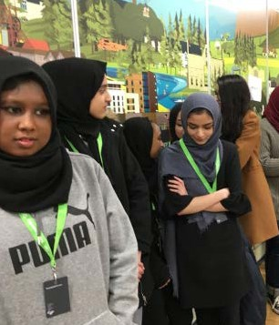
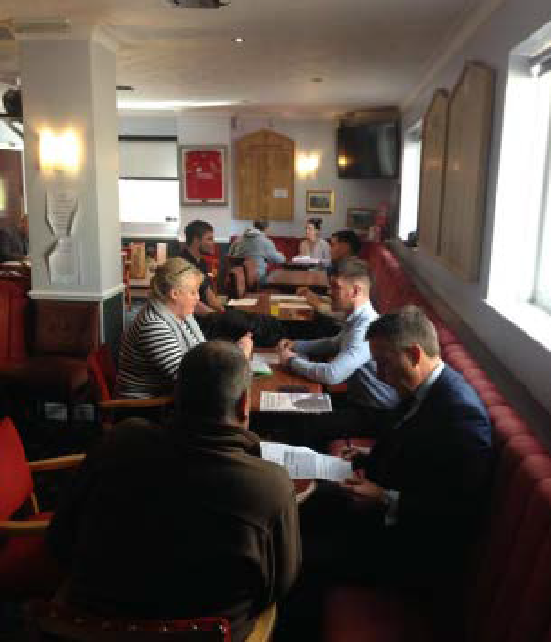

Young people from Newport and Cardiff involved in an out of school leadership programme called i-lead visited the Assembly in March
2018. The visit was organised with the Muslim Council for Wales and brought together young leaders from
the two communities. During the half day visit young people participated
in a debate in the Assembly’s original debating chamber, received a tour
of the Senedd, and took part in the Assembly’s consultation on electoral reform.

Photos
The Assembly’s rugby team continues to take an ambassadorial role, promoting the Assembly and engaging with diverse groups. They have played in charity matches
to raise money for Bowel Cancer Research and Shelter, played the Worcester Warriors mixed ability team, the Cardiff Lions and Swansea Vikings LGBT-inclusive teams, and have engaged with the School of Hard Knocks, a social inclusion charity which uses sport to tackle the issues surrounding unemployment, antisocial behaviour and crime.
The team have held employability sessions with members of the latter in order to support them back into the workplace.

Left: Young people from Newport and Cardiff attend an understanding and engaging session organised by the Muslim Council for Wales.
Right: The Assembly’s rugby team discussing employability skills with members of the School of Hard Knocks.

Visitors, tours and events

We promote the Assembly as a visitor attraction through connections with the local Cardiff Bay Waterfront Partners Group, through social media, through our outreach work and through Euan’s Guide, a listings and review website that helps disabled people and their families know which venues are accessible.

We have made adjustments to enable visitors to participate in tours by adjusting the speed of tours and the complexity of language used.

We have hosted a vast array of inclusion-related events throughout the year including events to mark LGBT History Month, International Women’s day, Chinese New Year, a Christian heritage exhibition, elder abuse, young carers, West African community links, India Centre lecture, Srebrenica memorial, Black History Month launch, dementia care, White Ribbon Day, Elimination of Racial Discrimination, modern day slavery, anti human-trafficking, BAME LGBT awareness, preventing child sexual assault, and the Special Olympics.

The team on events, security and the front of house team were extremely respectful, helpful and sensitive to the various needs of our guests.
Feedback following a disability event at the Senedd

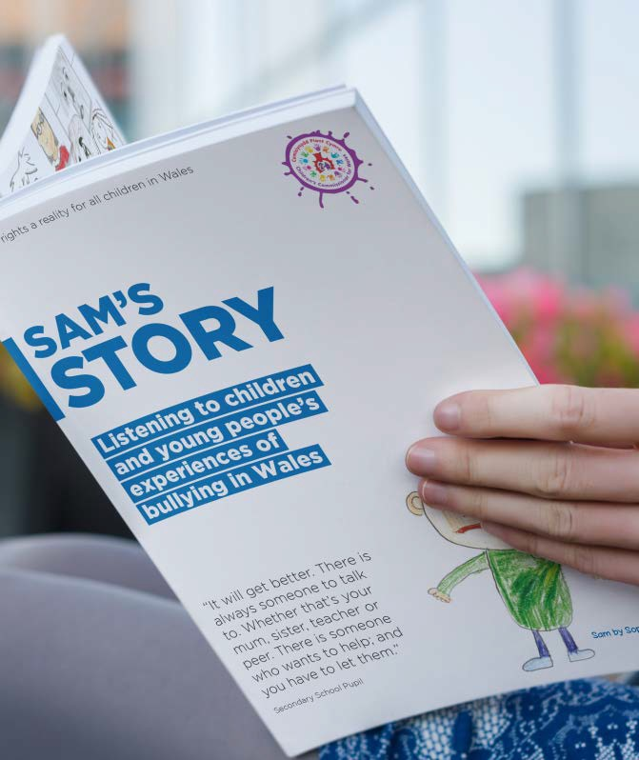

Sam’s Story exhibition

Sam’s Story was an exhibition organised in collaboration with the Children’s Commissioner for Wales on the issue of bullying amongst young people.
Visitors, young visitors in particular, were asked to engage with the exhibition by completing a Sam’s Story postcard. The postcards were used to populate a report which was later published by the Children’s Commissioner for Wales.

Promoting diversity and inclusion

As part of our commitment to being an inclusive organisation we continue to promote diversity and inclusion internally and to the public via events, social media and campaigns. We have encouraged people to think of the Assembly as an inclusive organisation, encouraging them to get involved with the work of the Assembly and to consider the Assembly as a potential employer of choice.
Here are some of the highlights of our promotional work:
  - We attended PRIDE Cymru, where Assembly Members and staff marched alongside many other organisations and individuals as part of the official Pride parade before welcoming attendees to our outreach bus on the main site.
  - We have used social media to mark events throughout the year, such as Trans Day of Remembrance, Holocaust Memorial Day, Autism Awareness Week, International Day Of Disabled People, Mental Health Awareness Week, Disabled Access Day and LGBT History Month.
  - To mark Autism Awareness month we published a number of social media posts to promote Autism Awareness activates taking place in the Senedd. We published 3 tweets across our English and Welsh language feeds over a 2 week period which, collectively, achieved a reach of 11,562 and delivered 251 engagements.
  - Black History Month (BHM) celebrates, recognises and values the inspirational individuals and events from within the BAME communities. This year, alongside internal awareness-raising activity, we hosted the launch of Black History Month and BHM Youth Awards; attended the Welsh Black, Asian, Minority Ethnic Public Sector Network “Learning from the best” event to share knowledge and best practice; our REACH network created an event to explore ‘Black History Month in Britain and the black mental health experience’; and we attended the BHM closing event in the Wales Millennium Centre.

Photos
Right: Attendees marking Black History Month visiting the Assembly’s stand

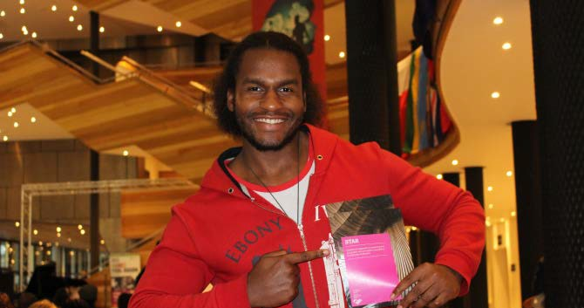
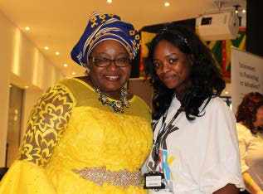
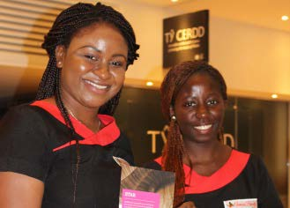
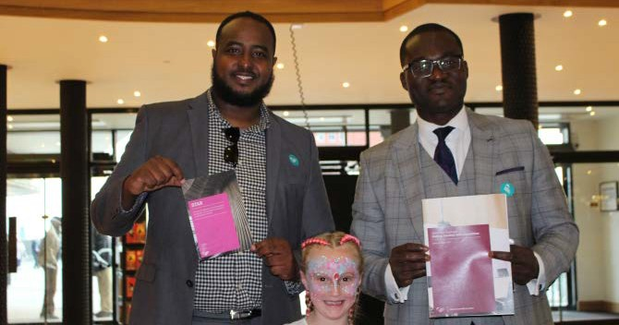

Wales, Women and Politics

The Deputy Presiding Officer, Ann Jones AM, established the Wales, Women and Politics Working Group to consider the specific issues relating to the role of women parliamentarians. The working group builds on the previous Assembly’s Women in Democracy Group and its role is to assist the Assembly Commission in recognising the part played by women in Welsh politics. In the short term, this focuses on feeding into events around the centenary since the passing of the Representation of the People Act 1918, when some women were granted the right to vote. Members of the group took part in many of the events held on and around International Women’s Day, 8 March.
Chwarae Teg - LeadHERship shadowing event

We partnered with Chwarae Teg to facilitate shadowing opportunities for young Welsh women with Assembly Members. The day included a question and answer session with some female AMs and a mock debate in Siambr Hywel.
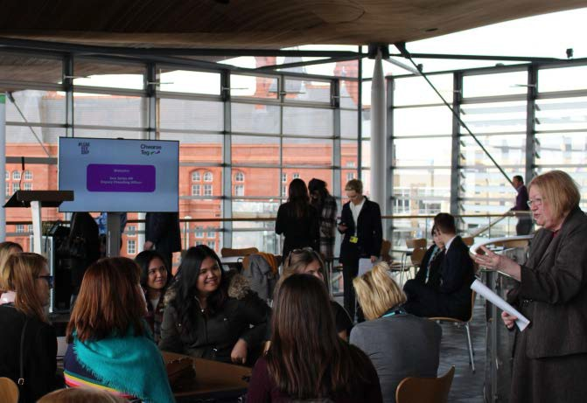

Photos
Left page: The Deputy Presiding Officer, Ann Jones AM, with attendees at the LeadHERship
shadowing event.
Right page: The purple plaque on the Senedd in memory of Val Feld.

Exhibition: Women’s suffrage movement in Wales

We worked in partnership with the National Museum of Wales and Cardiff University to host an exhibition of Women’s Suffrage in Wales that explored the various ‘vote for women’ movements present in Wales from the late nineteenth century to the beginning of the First World War. It also drew a parallel between the situation then and the state of gender equality in the Assembly and across Wales today.

The exhibition was seen by over 3800 visitors. To ensure wide appeal we organised a Senedd trail suitable for children aged 5+ and a banner-making workshop where people of all ages, but particularly children, were encouraged to make a banner about issues important to them just as the Suffragettes did 100 years ago.

Wonderful and just brought a smile as I looked at these wonderful women.

Wonderful insight & accessible, very inspiring. Please do more! I loved it !
Inspiring! A wonderful exhibit! Great displays. So proud of all this!

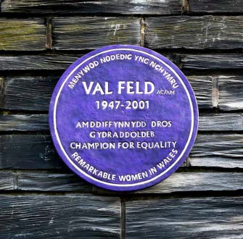
Purple Plaque
In addition to launching the exhibition, the event was also used to unveil
a plaque in memory of equality campaigner Val Feld. The plaque is part of the wider campaign being run by the Welsh Government in partnership with the Women’s Equality Network and Chware Teg to celebrate notable women (past and present) who have made a significant contribution to Welsh society and history.

Women and Activism: Past and Present

This event focused on women’s activism, linking together the past and present through a series of talks and round table discussion. The Women’s Archive of Wales Anniversary round table celebrated the achievements of the Archive in both preserving a history of women’s activism.

Book launch: Rocking the Boat: The Welsh Women who Championed Equality 1840 – 1990 – Prof. Angela John
The book “Rocking the boat” focuses on seven Welsh women who resisted the status quo in Wales, England and beyond during the nineteenth and twentieth centuries, challenges expectations about how women’s lives were lived in the last two centuries, and raised issues of gender and nationality. The book launch took place in the Senedd in partnership with Parthian.

Girlguiding Wales
Girlguiding Cymru celebrated International Women’s Day with a look at ‘Being Our Best’, its strategic plan until 2020. The purpose of the event was to highlight the work of Girlguiding Cymru in its role of empowering girls and young women.

Ursula Masson 10th Annual Memorial Lecture (Including performances by the Welsh National Opera)
The Ursula Masson Memorial Lecture is held each year in memory of Dr Ursula Masson, a highly esteemed Lecturer in History at the former University of Glamorgan. Dr Masson was instrumental in founding the Women’s Archive of Wales. This year’s lecture was delivered by Ryland Wallace, author of “The Women’s Suffrage Movement in Wales, 1866 – 1928”. The Welsh National Opera used the event as an opportunity to promote “Rhondda Rips it Up!”, a suffragette themed opera that’s due to launch in Newport in June 2018.

Political Studies Association Event – “Twenty years after devolution: where are the women?”
This event was sponsored by the PSA Women and Politics Group, National Assembly for Wales and the Learned Society for Wales. The Deputy Presiding Officer, Ann Jones AM chaired a discussion with three practitioners and academics, who each addressed one devolved area of the United Kingdom and the challenges and opportunities that each has presented for women’s representation.

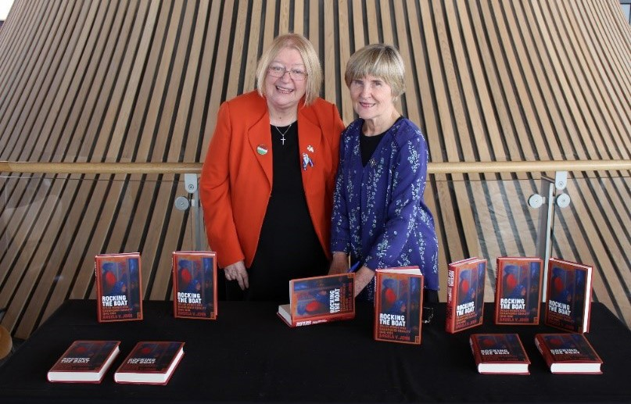
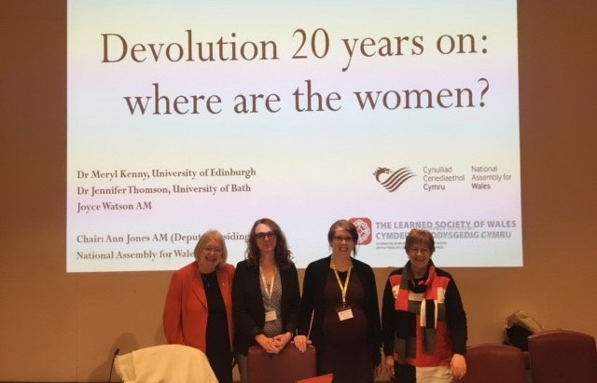

Photos
Top: The Deputy Presiding Officer, Ann Jones AM, at the 'Rocking the Boat' Book launch. Bottom: The Deputy Presiding Officer, Ann Jones AM at the Political Studies Association Event – “Twenty years after devolution: where are the women?”

Promoting inclusion beyond Wales
  - Ann Jones, AM attended the Commonwealth Parliamentary Association’s Inaugural Conference for Parliamentarians with Disabilities which took place in August 2017 in Halifax, Canada. The conference provided an opportunity for participants to share best practice and personal experiences. Attendees from across twelve Commonwealth countries were present at the conference to discuss how parliamentarians with disabilities can play a full and equal role within the parliamentary environment. Ann Jones AM took this opportunity to showcase the Assembly as an exemplar of inclusion and cited the Senedd as a modern, transparent and fully accessible parliamentary building.

  - Joyce Watson AM serves as the Chair of the British Island and Mediterranean (BIM) Region of the Commonwealth Women Parliamentarians. She represents the interests of women from 13 legislatures from the UK, Europe and as far as the Falkland Islands and St Helena. Joyce has also been honoured to be elected for 2017-18 as the Vice-Chair of the CWP internationally.
  - We hosted the annual BIM Regional Commonwealth Women Parliamentarians Conference at the Senedd. This year's theme was 'Women in the Economy' and delegates heard a series of talks on issues including the role of government in promoting women in the economy, the diversity of women in the economy, and minding the gap: Women in construction. The aim of the conference was to collaborate, challenge and inspire change – to identify the barriers preventing women from fulfilling their potential as well as the gaps in policy and strategy and to share good practice. The Assembly was praised for its fresh and innovative approach to the Conference, further details of which can be found on the Assembly’s website.

  - A member of our Research Service worked with the UN Development Programme to provide expert support to the Fiji Parliament’s budget scrutiny in June 2017. This included conducting the country’s first budget gender analysis, and delivering a training session to all committee chairs on how to practically embed a gender perspective in legislative and budget scrutiny.

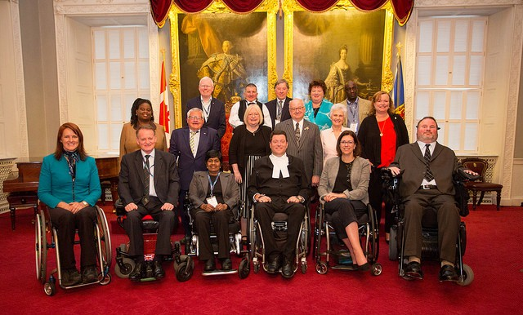
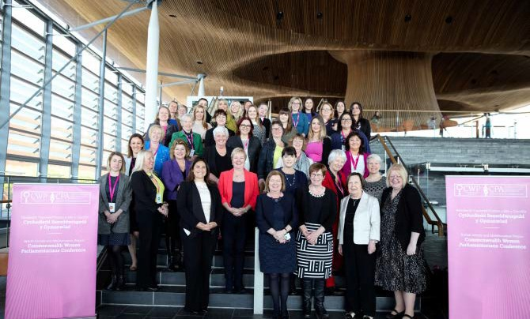

Photos
Top: The Deputy Presiding Officer, Ann Jones AM, and attendees at the Commonwealth
Parliamentary Association’s Conference for Parliamentarians with Disabilities.
Bottom: The Deputy Presiding Officer, Ann Jones AM, and Assembly Commissioner with responsibility for equality Joyce Watson AM join other Assembly members and parliamentarians at the British Island and Mediterranean Regional Commonwealth Women Parliamentarians Conference.

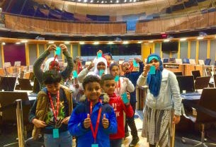
Youth Engagement

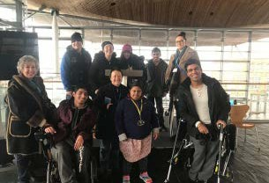
Our Education and Youth Engagement team have informed, involved and empowered children and young people to engage with Assembly Business both in our in- house education centre and at schools, colleges and out-of-school settings across Wales.

We have worked with 141 youth groups in out-of-schools settings, engaging with some groups for the very first time. During this reporting period, 21,135 young people have engaged with us during arranged educational sessions.

Photos
Top: Young people visiting the Senedd.
Middle: Students from Cardiff and Vale college visiting the Senedd
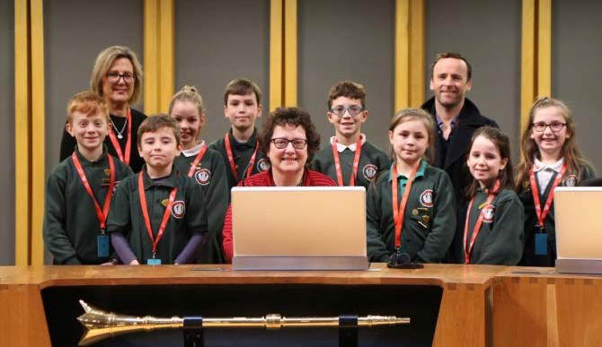
Bottom: Pupils from Ysgol y Wern with the Llywydd, Elin Jones AM, launching their school parliament.

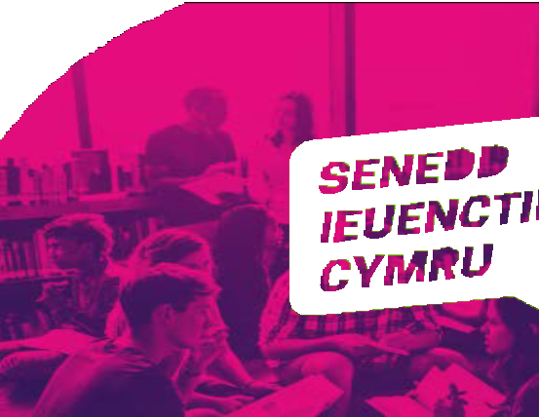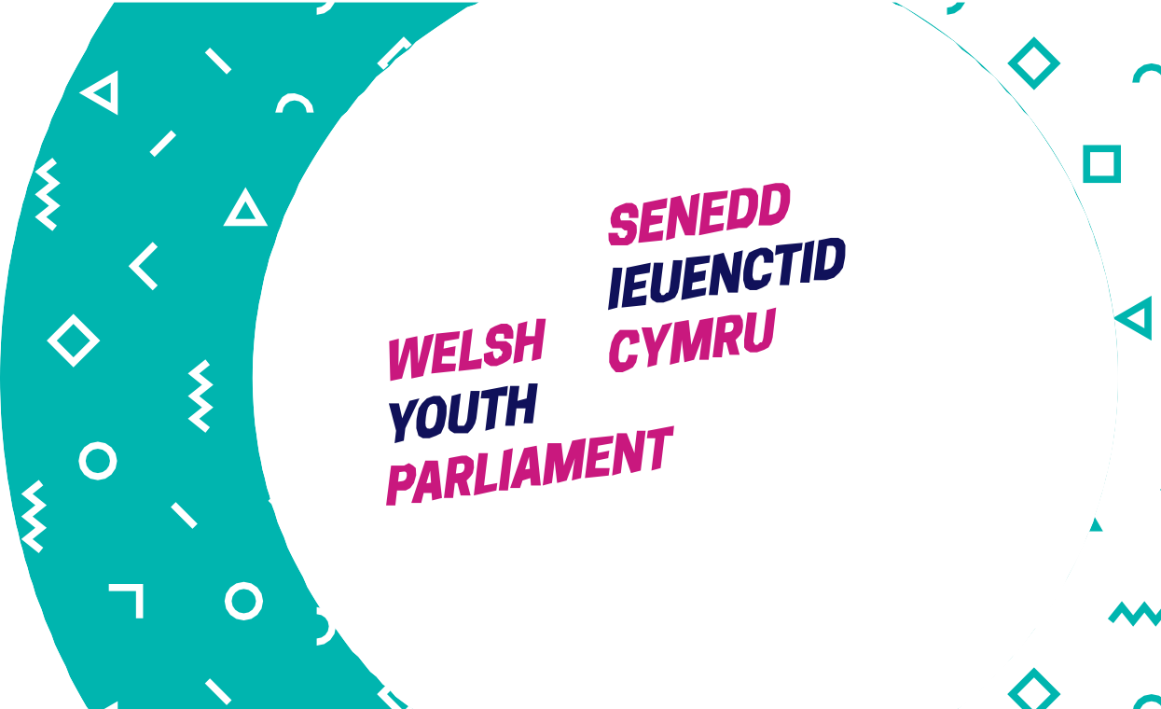

Welsh Youth Parliament
Over the last year, work has been undertaken to progress plans for the establishment of a Welsh Youth Parliament (WYP), Over 5,000 young people responded to our consultation on establishing a Welsh Youth Parliament, where they were asked for their views on its key principles, its name, how it should operate, and how Youth Welsh Parliament Members (YWPMs) should be returned.

Mi-Voice were procured to deliver online voting for the YWPMs for each of the 40 constituencies, and we have developed an approach to ensuring representation of diverse groups of young people, having consulted with a number of relevant bodies and organisations. We would like to thank all of those organisations and young people involved in our steering group for their input and advice which has shaped the development of the project.

An equality impact assessment was undertaken to ensure that inclusion considerations are built into the development of the WYP.

Work has begun to raise awareness and interest in the WYP, by attending a range of events and conferences involving young people, parents, guardians, education professionals and youth workers. Elections will take place over a three week period in November 2018, and Youth Welsh Parliament Members announced in December.

Accessible proceedings

To increase the online accessibility of our proceedings, we now show signed and subtitled First Minister’s Questions on the Assembly’s YouTube channel. The signed version is also available on Senedd.tv. Additionally, there is a dedicated section for signed proceedings on the Senedd Extra section of Senedd.tv, making it easier for users to find these recordings.
Committee work

Our committees are always keen to hear from different people to ensure that a range of views are considered during inquiries. We continue to utilise innovative methods of engaging with people in the work of the Assembly, promoting online conversations with a diverse range of communities across Wales. Over 15,000
people have had their say in the work of Assembly committees through surveys and online forums during this period.
During this period, our committees have covered a range of inquiries related to inclusion such as perinatal mental health, isolation and loneliness, youth participation in sport, Brexit and equalities, funding of the arts, refugees and asylum seekers, homelessness, children’s emotional and mental health, making the economy work for people on low incomes, pregnancy maternity and work, and public transport for disabled people.
We received evidence from a variety of stakeholders including many organisations hadn’t previously engaged with the Assembly’s Committees. We have engaged in a variety of ways to increase more people and make it easier for them to participate.
  - We have trialled a citizen’s panel, held focus groups, and undertaken visits to stakeholders and service users.
  - We have used online tools like the Dialogue App to ask people to anonymously share their experiences. This process meant that the committee had contributions from people who would not normally submit written evidence.
  - We have made adjustments for participants to encourage their participation, such as giving evidence anonymously in a private session, producing information in accessible formats like Easy Read, and arranging for registered nursery nurses to look after young children and babies to enable their parents to fully engage in discussions.

Equality, Local Government and Communities Committee
We held focus groups across Wales for their inquiry into making the economy work for people on low incomes. Contributions were gathered from a mixture of frontline staff, and service users including young people, low income families, and single parents. Some of the contributors were employed, some were in part time work or zero hours contracts, and others were out of work. Eight sessions were held in total, and the views of the contributors have been summarised into key themes, which included public transport, the benefits system, job opportunities, and advice and support.

Children, Young People and Education Committee
As part of the Emotional and Mental Health of Children and Young People inquiry we held a meeting with over 40 frontline professionals, and undertook two online surveys – one for children and young people in secondary school/college and one for education professionals. The committee also visited specialist in-patient units, a primary school, a third sector youth project and a secure children’s home.

Equality, Local Government and Communities Committee
As part of the inquiry into pregnancy, maternity and work, we used the Dialogue App to ask people to anonymously share their experiences. This process meant that the committee had contributions from people who would not normally submit written evidence and enabled people to propose suggestions on what the Welsh Government should do to tackle issues. Contributions covered a range of topics including the childcare, the availability of childcare facilities at the workplace, and the availability of part-time jobs. The committee also ran a one-day focus group event which was open to the public to attend and attendees were able to bring children to the event.

Petitions Committee:
We held an inquiry into the accessibility of public transport for disabled people, following a petition submitted by a group of young people from the charity Whizz-Kidz. The committee held a session with the young people in an informal environment to understand their experiences in more detail, and then held
evidence sessions with companies that provide public transport, local government and the Welsh Government. This evidence was used to produce a report containing 12 recommendations for how public transport services could be improved for people with disabilities and a plenary debate on the subject was held in January 2018.

Diversity and Inclusion in our work
Equality Impact Assessments (EQIAs) and considering equality in our work

We continue to consider equality, diversity and inclusion as part of our ongoing work, when developing policies, services and making changes to our estate. For example, the business analysis team have worked to embed the principles of equality into business improvement initiatives throughout the Assembly by:
  - Advising project teams on the need for an EQIA;
  - Ensuring equality and diversity are represented in requirements documents when developing new projects; and
  - Considering the needs of all stakeholders of change and ensuring they are represented.
Accessible estate

We continually review the accessibility of our estate, undertaking monthly maintenance audits, as well as acting on feedback and adopting best practice. During this reporting period, we have undertaken further work to improve the physical accessibility of our estate, including:
  - installing new signage, including braille, to the committee corridor in Ty Hywel;
  - considering access requirements for all refurbishment work that have been carried out and completing Equality Impact Assessments as required;
  - continuing with the programme of installing LED lighting to improve visibility in the Senedd and other areas across the estate; and
  - installing signage to hand dryers throughout the estate warning of loud noise when in use.
We have placed a breastfeeding chair in the Senedd. Following a consultation the chair was placed within the Senedd café ensuring it is in a discreet area should the user require a slightly more private space. We do however have quiet rooms available. These rooms can also be used as sensory spaces or ‘calm’ areas, which can be particularly helpful for children with autism.

Expert Panel on Assembly Electoral Reform

Equality and diversity were central to the work of the Expert Panel on Assembly
Electoral Reform. One of the principles against which the Panel assessed different electoral systems was "Diversity: the system should encourage and support the election of a body of representatives which broadly reflects the population". Chapter 12 of the Panel's report considers a range of issues relating to diversity of representation, in particular how to sustain the Assembly's record in relation to the representation of women.
Reform of the Assembly: Creating a Parliament for Wales

The Assembly Commission is leading work to explore how the powers in the Wales Act 2017 might be used to make the Assembly an accessible and forward-looking legislature with the capacity and internal arrangements it needs to represent the people of Wales. As part of the consultation we prepared an Easy Read document, developed a dedicated and accessible microsite, and targeted information to young people. Over 400 young people from across Wales took part in workshops led by the Assembly's Outreach and Education teams.
The Assembly Commission will publish a report on the consultation in due course. If the Commission decides to introduce legislation to give effect to the reforms, equality impact assessments will be completed at that stage.
Procurement

We take every opportunity to champion equality throughout the procurement process and ongoing contract management. Equality is included as part of our sustainability risk assessments at the very start of the procurement process. It also forms part of our pre-qualification exercise for suppliers. Suppliers who fail to demonstrate their commitment to equality are not invited to tender. Post contract-award, we conduct regular contract review meetings with our suppliers. One of the standard agenda items is corporate social responsibility. We also have equality clauses in our terms and conditions. We are an accredited living wage employer and ensure that the living wage is paid to our in-house contractors. We are committed to ensuring fair and transparent employment practices are in place throughout our supply chain. Consequently we seek to work with our suppliers to monitor and ensure fair employment practices and, acting reasonably, we reserve the right to request changes to any of those practices we consider to be unfair.

MySenedd

We have continued to consider inclusion and accessibility as part of our MySenedd programme, a series of projects designed to improve the way we manage and use information, deliver services to Members and interact with all our users through the use of technology. The programme aims to create a truly outstanding, open, digital parliament. Progress to date includes:

- publishing Assembly Business on a fully searchable platform that has been designed to improve accessibility for users;
- redesigning the 'Record' website at an A grade accessibility level which gives
users the best experience they can have with a range of needs

- Dragon is the software our translation service use for voice recognition and helps users with sight impairments, repetitive strain injuries etc. Again this was tested with Dragon users to make sure it was suitable and up to standard.

- Social media sharing - this enables the Table Office and Record to be more accessible to more users. We have seen a big uplift in the number of shares on the site and people using the web page.

Feedback from Members and their staff indicates that users find the new Table Office application more accessible.

Research and information

The principles of diversity and inclusion are incorporated in much of the research and analysis produced to support Assembly Members’ and committees in their
work. Our Research Service has also produced b log articles and publications on
equality issues throughout the year. In addition, our library maintains a wide range of information sources on equality, diversity and inclusion to support the work of the Assembly and to support our staff. Some of the work undertaken to embed diversity and inclusion in our work during this reporting period includes:

  - Updating g ender equality indicators for Wales for the second year, and
providing commentary to help Members scrutinise policies, legislation and budgets from a gender perspective. This was published to tie into the Assembly’s debate on International Women’s Day;
  - providing suggested questions for each committee on equality during the draft budget scrutiny;
  - publishing a range of blog posts on equality issues, such as Brexit’s impact on equality and human rights, violence against women, refugees and asylum seekers, rights of disabled people, poverty and welfare; and
  - ensuring equality is integrated in the drafting of suggested terms of reference for committee inquiries (such as the Equality, Local Government and Communities Committee’s i nquiry into pregnancy, maternity and work; the Children, Young People and Education Committee’s inquiry into the impact of the Education Improvement Grant on Gypsy, Roma and Traveller and minority ethnic children, and the Health and Social Care Committee’s inquiry into suicide prevention, which explored experiences of different groups of people, particularly men).

What next?
Actions for 2018-19

  - The Assembly Commission will consider the responses to the consultation on Assembly reform in the summer of 2018, and will publish a report on the consultation in due course. If the Commission decides to introduce legislation to give effect to the reforms, equality impact assessments will be completed at that stage.
  - In 2018 the Assembly will establish the first Welsh Youth Parliament, with elections taking place over a three week period in November, and Youth Welsh Parliament Members announced in December.
  - We will review the recommendations that come out of the Speaker’s BAME challenge and the results of our recruitment review to ensure that we continue to consider equality, diversity and inclusion in our recruitment and development work. We will develop our communications around recruitment to encourage more people to consider us as an employer of choice.
  - We will undertake further work to encourage job applicants and staff to provide their equality monitoring data.
  - We will build on our approach to ensuring dignity and respect in the Assembly, with a new policy, making sure that everyone is are aware of all of the appropriate reporting routes. We will ensure that everyone who needs support is given it, so that they can recognise and report inappropriate behaviour.
  - We will continue to review and improve the accessibility of our estate by complete the rolling refurbishment of the Tŷ Hywel lifts to include LED lighting, accessible lift buttons and new signage, including braille, carrying out a full audit and test of all hearing loops on the estate, and reviewing the current provision of external signage to the Senedd identifying accessible ramps and make improvements as necessary.

  - Following its inaugural meeting, a case was put forth to the Commonwealth Parliamentary Association for the ‘Commonwealth Parliamentarians with Disabilities’ (CPwD) to be endorsed and established as a standalone network within the Association. The Assembly will strive to participate fully and to promote this network.
  - We are investigating ways to increase the diversity of people who undertake work placements and work experience at the Assembly.
  - We will monitor outcomes of Apprenticeship Scheme to review our inclusive approach.
  - We will continue to look at external benchmarking and accreditation exercises to ensure that we remain an employer of choice and an inclusive organisation.
  - We will continue to build access and inclusion into our MySenedd programme of activities.

Annex A: Monitoring Information

Our workforce exists to support the efficient running of the National Assembly for Wales by providing services to Assembly Members, their staff and the public. Each year, we collect, analyse and publish diversity data on our workforce profile and recruitment activity.
The information below sets out an analysis of the diversity profile of our workforce, alongside both internal and external recruitment monitoring data. From this information, we are able to examine the diversity profile of our workforce, the people we attract to apply for jobs and to whom we offer employment. We use the analyses of these monitoring exercises to help us ensure that we meet the diverse needs of staff and to try to ensure that our workforce represents the public that we serve.
The preparation and publication of this report meets the public sector duties set out in the Equality Act 2010. The report contains analyses of data which accords with the protected characteristics as defined by the Act.
As 98% of our workforce is based in Cardiff Bay, we are using data from the 2011 Census, namely the Cardiff Travel to Work Area (TTWA) data set to compare the characteristics of our workforce and job applicants to the wider Cardiff population in terms of people of working age.

Our Approach to Workforce Monitoring
Our workforce data is collated via our HR Payroll system and relates to staff directly employed by the Assembly Commission. The workforce data presented in this report is as of 31 March 2018.
One of our identified on-going actions is to further increase the number of staff who self-identify their diversity characteristics and update them on our HR Payroll system. We include declaration rates alongside our workforce data.

Our Approach to Recruitment Monitoring
The Assembly Commission’s recruitment policy is designed to be flexible: managers can access a series of prompt questions to assist them to determine whether they need to advertise vacancies internally, externally or both concurrently. The recruitment data presented in this report cover both internal and external recruitment schemes that closed with appointments during the reporting period of 1 April 2017 to 31 March 2018. As such, this includes schemes which were advertised in the 2016-17 reporting period where the appointment was not made until after 1 April 2017. The external recruitment data includes Assembly Commission staff who applied for vacancies which were advertised externally. During the reporting period there were 25 internal recruitment schemes and 49 external recruitment schemes.
During this reporting period, we have encouraged all applicants to submit their diversity monitoring data in order to complete the application process. Our Recruitment Team has proactively contacted applicants to complete the forms (with a choice including ‘prefer not to say’) if they have not already done so.
The internal recruitment data covers schemes that closed between April 2017 and March 2018 and includes all formal internal schemes, whether temporary or permanent.

Action to address under-representation in our workforce
We are taking steps to address under-representation within our workforce, including identifying and removing barriers to inclusion. We are encouraging applications from the widest pool of talent and undertake outreach work to promote the Assembly as an inclusive employer. We deliver unconscious bias training for all recruitment panels and have undertaken an equality review of our recruitment policy and practices.

Understanding our recruitment statistics
The recruitment tables below for both internal and external recruitment schemes track the success rates of applicants throughout the recruitment process as follows:
- Under “Applications Received” we present the number of applicants per category and that number as a percentage of the total number of applications.
- Under “Successful at sift” we present the number of applicants per category who have been invited to interview and that number as a percentage of the number of applicants in that category.
- Under “Offer of employment” we present the number of applicants per category who have been offered a job and that number as a percentage of those who were successful at sift.
- Under “Overall success rate” we present the success of people in that category as a percentage – i.e. the percentage of total applicants from that category who have been successful. For external schemes we compare the success rate with that of the last reporting period (2016-2017), but not for internal schemes as this information is only available this year for the first time.
- Finally, we present the percentage of jobs that were offered to people in each category.

Privacy
Raw data is only seen by a small number of key staff in the HR Team and is held securely on a confidential basis and in line with data protection legislation. In terms of our workforce data and presentation, where there are small numbers of staff, we have merged certain categories within the tables in the report to ensure that individuals’ privacy is protected which is also in line with data protection legislation.

Workforce composition
Table 1: Workforce Composition by grade

Grade | Number as at 31 March 2018 | % at 31 March 2018
Senior Staff, including Chief Executive and Directors | 5 | 1.1
Executive Band 1 | 15 | 3.2
Executive Band 2 | 52 | 11.1
Management Band 1 | 76 | 16.2
Management Band 2 | 129 | 27.6
Management Band 3 | 70 | 15.0
Team Support | 121 | 25.9
Apprentices | 0 | 0.0
Total | 468 | 100.0

Head count as of 31 March 2018: 468 staff (this includes three staff who were either seconded staff to the Assembly Commission or are agency staff). This compares with 466 staff in the last reporting period.

Age
Table 2: Workforce age profile

Age range | Number | % of total workforce | % total 2016-17 | % Change
Under 21 | 1 | 0.2 | 0.6 | -0.4
21-25 | 22 | 4.7 | 5.6 | -0.9
26-30 | 59 | 12.6 | 13.9 | -1.3
31-35 | 95 | 20.3 | 20.4 | -0.1
36-40 | 82 | 17.5 | 17.0 | 0.6
41-45 | 68 | 14.5 | 12.0 | 2.5
46-50 | 42 | 9.0 | 10.7 | -1.8
51-55 | 41 | 8.8 | 9.0 | -0.3
56-60 | 40 | 8.5 | 7.5 | 1.0
61-65 | 16 | 3.4 | 3.0 | 0.4
65+ | 2 | 0.4 | 0.2 | 0.2
Total | 468 | 100.0 | 100.0 | 0.0
Disclosure rate: 100.0%

Analysis:

The age composition of our workforce has remained fairly static since 2014.
According to data from the 2011 Census, 14.3% of people in the Cardiff Travel to Work Area (TTWA) who are economically active and employed are aged under 24. This compares to 4.9% of our workforce who are aged 25 and under. This has dropped from 6.2% as reported in our last annual report.
  - % of our workforce is aged between 51 and 65. This has risen from 19.5% in our last annual report. This compares to data from the 2011 Census which states that 23.9% of people who are economically active and employed in the Cardiff TTWA are aged 50 to 64.
We will continue to attract young people and older people into our workforce. During this period we have advertised our latest apprenticeship scheme and have removed the upper age limit for applicants. We have promoted the Assembly as an employer of choice through recruitment outreach and will by offering work placements to a more diverse pool.
The largest group of staff by age range is 31-40 group which represents 37.8% of all staff.

Table 3: Internal Recruitment by Age

Applications received |  |  | Successful at Sift |  | Offer of Employment |  | Overall Success | % of total job offers
Age Range | Number | % of total applications | Number | % of applications successful at sift | Number | % of those successful at sift offered employment | % | %
<20 | 3 | 4.1 | 1 | 33.3 | 0 | 0.0 | 0.0 | 0.0
20 - 29 | 26 | 35.1 | 21 | 80.8 | 12 | 57.1 | 46.2 | 42.9
30 - 39 | 33 | 44.6 | 23 | 69.7 | 10 | 43.5 | 30.3 | 35.7
40 - 49 | 5 | 6.8 | 3 | 60.0 | 3 | 100.0 | 60.0 | 10.7
50 - 59 | 3 | 4.1 | 1 | 33.3 | 1 | 100.0 | 33.3 | 3.6
60< | 0 | 0.0 | 0 | 0.0 | 0 | 0.0 | 0.0 | 0.0
No Reply | 3 | 4.1 | 3 | 100.0 | 1 | 33.3 | 33.3 | 3.6
Prefer Not To Say | 1 | 1.4 | 1 | 100.0 | 1 | 100.0 | 100.0 | 3.6
Total | 74 | 100.0 | 53 | 71.6 | 28 | 52.8 | 37.8 | 100.0

Analysis:

    - The majority of both applications and appointments came from those aged 20-39, reflecting the external recruitment data below.
    - Only one person over the age of 50 was offered employment.

Table 4: External Recruitment by Age

 | Applications Received |  | Successful at Sift |  | Offer of Employment |  | Overall Success
Age Range | Number | % of total applications | Number | % of applications successful  at sift | Number | % of those successful at sift offered  employment | % 2017-2018 | % 2016-2017 | % of total job offers
<20 | 10 | 1.5 | 5 | 50.0 | 1 | 20.0 | 10.0 | 9.5 | 2.2
20 - 29 | 206 | 31.2 | 73 | 35.4 | 17 | 23.3 | 8.3 | 7.8 | 37.0
30 - 39 | 244 | 36.9 | 90 | 36.9 | 17 | 18.9 | 7.0 | 7.0 | 37.0
40 - 49 | 97 | 14.7 | 31 | 32.0 | 6 | 19.4 | 6.2 | 4.9 | 13.0
50 - 59 | 56 | 8.5 | 16 | 28.6 | 2 | 12.5 | 3.6 | 10.4 | 4.3
60< | 2 | 0.3 | 2 | 100.0 | 1 | 50.0 | 50.0 | 14.3 | 2.2
No Reply | 37 | 5.6 | 15 | 40.5 | 2 | 13.3 | 5.4 | 0.0 | 4.3
Prefer Not To Say | 9 | 1.4 | 2 | 22.2 | 0 | 0.0 | 0.0 | 25.0 | 0.0
Total | 661 | 100.0 | 234 | 35.4 | 46 | 19.7 | 7.0 | 9.1 | 100.0

Analysis:

    - The percentage of applications with No reply has increased for the first time since 2014, from 1.0% in 2016-2017 to 5.6% in 2017-2018. Our recruitment team have proactively contacted people to increase declaration rates so while the decrease in reporting is disappointing, we will continue to update our communications and website to encourage applications.
    - By far, the most applications continue to be from 20-39 year olds, with the highest number of appointments from this group.
    - The number of people aged over 50 offered employment has decreased from nine in 2016-2017 to three in 2018- 2018. The success rate for people aged over 50 is lower at 3.6% than other age groups.
    - 6.5% of all jobs went to people aged over 50, compared to 14.8% of total job in the last reporting period. This is significantly below the Census 2011 Travel to Work data that states that 23.9% of economically active people in the TTWA are 50-64.

Disability
Table 5: Workforce disability profile

Grade | Total staff | Disabled staff |  | Non-disabled staff |  | Not Disclosed |  | % disabled staff
 | number | Number | % | number | % | number | % | 2018 / 2017
TS | 121 | 8 | 6.6 | 104 | 86.0 | 9 | 7.4 | 6.6 / 7.7
M3 | 70 | 5 | 7.1 | 63 | 90.0 | 2 | 2.9 | 7.1 / 4.5
M2 | 129 | 10 | 7.8 | 101 | 78.3 | 18 | 14.0 | 7.8 / 8.0
M1 | 76 | 1 | 1.3 | 69 | 90.8 | 6 | 7.9 | 1.3 / 1.4
E2* E1  Senior | 72 | 4 | 5.6 | 68 | 94.4 | 0 | 0.0 | 5.6 / 4.2
Total | 468 | 28 | 6.0 | 405 | 86.5 | 35 | 7.5 | 6.0 / 5.8
- merged to protect individuals’ privacy Disclosure rate: 92.5%

Analysis:

  - The percentage of staff who declared a disability as at 31 March 2018 was 6.0% of our total workforce, an increase from 5.8% in 2017. We will continue to encourage all disabled staff to record their disability on the HR system, as we believe that many people with mental ill health, dyslexia and other long term health conditions who could identify with this definition of disability on our system, are not reflected in this data.
  - The data shows that 82% of our staff who identify as disabled are at the three lowest pay grades. 5.6% of the E2, E1 and Senior grades identify as disabled (up from 4.2% last year) which is encouraging but we will continue to encourage staff to disclose their disability status on our self-service HR system.
  - The 2011 Census states that 8.3% of people who are economically active and employed in the Cardiff TTWA have a long-term health problem or disability that limits their day to day activities. As 6.0% of our workforce currently identifies as disabled, we would like this figure to align more with the Cardiff TTWA figure. We realise that this could involve encouraging staff to self-identify as disabled staff but also we need to be sure that we are attracting disabled people to apply for work with us. We will therefore take account of this as part of a wider strategy to address underrepresentation in our workforce.

Table 6: Internal Recruitment by Disability

Applications Received |  |  | Successful at Sift |  | Offer of Employment |  | Overall Success | % of total job offers
Disability | Number | % of total applications | Number | % of applications successful at sift | Number | % of those successful at sift offered  employment | % | %
Disabled | 6 | 8.1 | 3 | 50.0 | 1 | 33.3 | 16.7 | 3.6
Non- Disabled | 64 | 86.5 | 46 | 71.9 | 25 | 54.3 | 39.1 | 89.3
No Reply | 4 | 5.4 | 4 | 100.0 | 2 | 50.0 | 50.0 | 7.1
Prefer Not To Say | 0 | 0.0 | 0 | 0.0 | 0 | 0.0 | 0.0 | 0.0
Total | 74 | 100.0 | 53 | 71.6 | 28 | 52.8 | 37.8 | 100.0

Analysis:

  - Of the six disabled applicants, one was offered a job, giving an overall success rate of 16.7%, which is considerably lower than the success rate for non-disabled staff (39.1%).
  - We will continue to work on making sure that staff are comfortable in declaring a disability and will work with our disability network to encourage disabled staff to consider their development within the organisation.

Table 7: External Recruitment by Disability

 | Applications Received |  | Successful at Sift |  | Offer of Employment |  | Overall Success |  | % of total job offers
Disability | Number | % of total applications | Number | % of applications successful at  sift | Number | % of those successful at sift offered  employment | % 2017-2018 | % 2016-2017 | %
Disabled | 46 | 7.0 | 14 | 30.4 | 3 | 21.4 | 6.5 | 12.5 | 6.5
Non-Disabled | 541 | 81.8 | 196 | 36.2 | 41 | 20.9 | 7.6 | 9.0 | 89.1
No Reply | 65 | 9.8 | 22 | 33.8 | 2 | 9.1 | 3.1 | 0.0 | 4.3
Prefer Not To Say | 8 | 1.2 | 2 | 25.0 | 0 | 0.0 | 0.0 | 0.0 | 0.0
Total | 661 | 100.0 | 234 | 35.4 | 46 | 19.7 | 7.0 | 9.1 | 100.0

Analysis:

  - The 2011 Census states that 8.3% of people who are economically active and employed in the Cardiff TTWA have a long-term health problem or disability that limits their day to day activities. 7% of applications received were from people who identified as disabled compared to last reporting year’s figure of 7.1%. The success rate at sift is 30.4% compared to last reporting year’s rate of 39.6%.
  - Three applicants who identified as disabled were offered employment this year as opposed to six people in the last reporting period.
  - The overall success rate for applicants who identify as disabled is 6.5% compared with 12.5% from the last reporting year. The success rate for applicants who identify as disabled is broadly in line with that of people who did not identify as disabled.
  - 6.5% of all people offered a job declared a disability, compared to 9.8% in 2016-2017.
  - The number of no replies has increased from 2.5% of total applications in 2016-2017 to 9.8% in 2017-2018.
  - Although the percentage for successful at sift is higher for non-disabled people (36.2%), the percentage of those offered employment is marginally higher for disabled people than non-disabled people (21.4% compared to 20.9%). It is difficult to draw conclusions as the numbers remain small.

Gender identity / Gender reassignment
  - No members of staff have identified as transgender.
  - The Assembly is listed as one of the top LGBT inclusive organisation in the UK in Stonewall’s Workplace Equality Index 2017. We celebrate this success and promote the Assembly as an employer of choice on social media, and at events such as Pride and Sparkle.
  - Staff have the ability to update their personal data and we are also encouraging staff to make sure that their information is correct and up to date.
Internal recruitment: As no members of staff have identified as transgender, there is no internal recruitment data to report.
Table 8: External Recruitment by Gender Reassignment

 | Applications Received |  | Successful at Sift |  | Offer of Employment |  | Overall Success |  | % of total job offers
Gender reassignment | Number | % of total applications | Number | % of applications successful at  sift | Number | % of those successful at sift  offered  employment | % 2017-2018 | % 2016-2017 | %
Transgender | 2 | 0.3 | 1 | 50.0 | 0 | 0.0 | 0.0 | 0.0 | 0.0
Non- Transgender | 586 | 88.7 | 211 | 36.0 | 43 | 20.4 | 7.3 | 9.4 | 93.5
No Reply | 68 | 10.3 | 21 | 30.9 | 3 | 14.3 | 4.4 | 0.0 | 6.5
Prefer Not To Say | 5 | 0.8 | 1 | 20.0 | 0 | 0.0 | 0.0 | 9.1 | 0.0
Total | 661 | 100.0 | 234 | 35.4 | 46 | 19.7 | 7.0 | 9.1 | 100.0

Analysis:

  - There has been an increase in the number of applications from people who identify as transgender, from one (0.1% of total applications) in 2016-2017 to two (0.3% of total applications) in 2017-2018.
  - No replies has increased from 3.3% in 2016-2017 to 10.3% in 2017-2018. This remains the highest number of no replies of all of the protected characteristics and it is difficult to draw conclusions as to why this might be.
  - While there are no comparative statistics for the Cardiff TTWA in relation to people who identify as trans, Stonewall estimate that approximately 1% of the population identifies as transgender. Because of the small numbers involved, it is difficult to draw conclusions about transgender applicants.
  - We will continue to encourage all applicants to declare their gender identity and will continue to promote the Assembly as an inclusive employer in order to encourage applications from trans people. We actively promote the Assembly by attending Pride and Sparkle events, promoting our support for International Day Against Homophobia, Biphobia and Transphobia, celebrating LGBT History Month and Trans Visibility day. We are also ranked the Top Employer in the UK in Stonewall’s Workplace Equality Index that is now trans-inclusive.

Race / Ethnicity
Table 9: Workforce race profile

Grade | Total staff | BAME* staff |  | Non-BAME staff |  | No Reply/Prefer not to Say |  | % of BAME staff
 | number | number | % | number | % | number | % | 2018 / 2017
TS | 121 | 11 | 9.1 | 105 | 86.8 | 5 | 4.1 | 9.1 / 9.2
M3 | 70 | 7 | 10.0 | 62 | 88.6 | 1 | 1.4 | 10.0 / 7.5
M2 | 129 | 0 | 0.0 | 123 | 95.3 | 6 | 4.7 | 0.0 / 0.0
M1 | 76 | 0 | 0.0 | 75 | 98.7 | 1 | 1.3 | 0.0 / 0.0
E2* E1  Senior | 72 | 2 | 2.8 | 65 | 90.3 | 5 | 6.9 | 2.8 / 4.2
Total | 468 | 20 | 4.3 | 430 | 91.9 | 18 | 3.8 | 4.3 / 4.3
- BAME = people from a Black, Asian and minority ethnic background Disclosure rate 96.2%

Analysis:

  - The disclosure rate for the race/ethnicity profile is encouraging. However, the number of staff who identify as BAME has remained the same as last year at 20. The percentage of BAME people in the total workforce has decreased
from 5.2% in 2016 to 4.3 % in 2018. The 2011 Census states that 6.8% of people who are economically active and employed in the Cardiff TTWA identify as BAME. We still continue to work to reverse this trend and aim for closer alignment with the TTWA figure of 6.8%. Both the TS and M3 grades exceed this comparison figure.
  - 55% (11) of our BAME staff are employed at entry level (TS grade).This has dropped from 69.6% (16) from 2016. This can be explained by the fact that four people who identified as BAME (TS pay band) left the organisation during the last reporting year (2016-2017). 10% of staff who identify as BAME are employed at decision-making level at E2, E1 and Senior Level, which has decreased from 15% the previous year although, caution should be exercised however as the data is sensitive to small changes in the cohort.
  - We can infer from the data that there is an uneven distribution of staff who identify as BAME across our workforce: 90% of staff who identify as BAME are in the two lowest pay bands (TS and M3), up from 85% last year. In pay bands M2 and M1, no staff identify as BAME. Given the declaration rate, this is concerning.
  - An action plan has been designed to address underrepresentation in the Assembly’s workforce which involves supporting our existing BAME colleagues to fulfil their potential and also ensuring we take appropriate steps to attract the widest range of talent to apply for jobs with us. Our senior champion for BAME colleagues and REACH, our Race, Ethnicity and Cultural Heritage workplace equality network are raising the profile of the network, both internally and externally. We also intend to incorporate this work into a wider strategy to address underrepresentation in our workforce via the development of an attraction strategy which is inclusive of all the protected characteristics.

Table 10: Internal Recruitment by Race / Ethnicity

 | Applications Received |  | Successful at Sift |  | Offer of Employment |  | Overall Success | % of total job offers
Ethnicity | Number | % of total applications | Number | % of applications successful at  sift | Number | % of those successful at sift offered  employment | % | %
BAME | 4 | 5.4 | 3 | 75.0 | 2 | 66.7 | 50.0 | 7.1
Non-BAME | 66 | 89.2 | 46 | 69.7 | 24 | 52.2 | 36.4 | 85.7
No Reply | 4 | 5.4 | 4 | 100.0 | 2 | 50.0 | 50.0 | 7.1
Prefer Not To Say | 0 | 0.0 | 0 | 0.0 | 0 | 0.0 | 0.0 | 0.0
Total | 74 | 100.0 | 53 | 71.6 | 28 | 52.8 | 37.8 | 100.0

Analysis:

  - 20% of our BAME staff (4 out of 20) applied to an internal recruitment scheme during this reporting period, two of whom were successful giving a 50% success rate. One of the positions was a promotion and the other was a lateral move to the same grade.
  - We will continue to use our action plan and to work with our REACH network to support the development of our BAME staff

Table 11: External Recruitment by Race / Ethnicity

 | Applications Received |  | Successful at Sift |  | Offer of Employment |  | Overall Success |  | % of total job offers
Ethnicity | Number | % of total applications | Number | % of applications successful at  sift | Number | % of those successful at sift offered  employment | % 2017-2018 | % 2016-2107 | %
BAME | 34 | 5.1 | 11 | 32.4 | 1 | 9.1 | 2.9 | 3.1 | 2.2
Non-BAME | 589 | 89.1 | 210 | 35.7 | 43 | 20.5 | 7.3 | 9.5 | 93.5
No Reply | 37 | 5.6 | 12 | 32.4 | 2 | 16.7 | 5.4 | 0.0 | 4.3
Prefer Not To Say | 1 | 0.2 | 1 | 100.0 | 0 | 0.0 | 0.0 | 0.0 | 0.0
Total | 661 | 100.0 | 234 | 35.4 | 46 | 19.7 | 7.0 | 9.1 | 100.0

Analysis:

  - The 2011 Census states that 6.8% of people who are economically active and employed in the Cardiff TTWA identify as BAME. The percentage of total applications from people who identify as BAME has increased slightly from 4.8% in 2016-2017 to 5.1% in 2017-2018, but has fallen significantly from 8.5% of total applications in 2015-2016. As such, the percentage of total applications is lower than the BAME populations in the Cardiff TTWA.
  - No replies increased from 1.5% in 2016-2017 to 5.6% in 2017-2018.
  - 2.2% of job offers were made to people who identified as BAME, although that represents only one person.
  - The gap between applicants successful at sift has decreased significantly, where BAME and Non-BAME successful applicants are broadly comparable (32.4% and 35.7% respectively). However, the difference at offer of employment stage and overall success rates are all significantly lower for people who identify as BAME.

Religion / belief
Table 12: Workforce religion / belief profile

Grade | Total staff | No religion |  | Christian* |  | Other** |  | No Reply/Prefer not to Say |  | 2018 | 2017
 | number | number | % | number | % | number | % | number | % | None/Christian/Other | None/Christian/Other
 |  |  |  |  |  |  |  |  |  | % | %
TS | 121 | 50 | 41.3 | 36 | 29.8 | 13 | 10.7 | 22 | 18.2 | 41 / 30 / 11 | 48 / 27 / 7
M3 | 70 | 30 | 42.9 | 18 | 25.7 | 5 | 7.1 | 17 | 24.3 | 43 / 26 / 7 | 39 / 24 / 6
M2 | 129 | 47 | 36.4 | 44 | 34.1 | 9 | 7.0 | 29 | 22.5 | 36 / 34 / 7 | 34 / 38 / 9
M1 | 76 | 26 | 34.2 | 29 | 38.2 | 10 | 13.2 | 11 | 14.5 | 34 / 38 / 13 | 30 / 40 / 14
E2 | 52 | 13 | 25.0 | 18 | 34.6 | 8 | 15.4 | 13 | 25.0 | 25 / 35 / 15 | 26 / 32 / 15
E1 | 15 | 3 | 20.0 | 7 | 46.7 | 1 | 6.7 | 4 | 26.7 | 20 / 47 / 7 | 21 / 43 / 7
Senior | 5 | 1 | 20.0 | 0 | 0.0 | 2 | 40.0 | 2 | 40.0 | 20 / 0 / 40 | 40 / 0 / 40
Total | 468 | 170 | 36.3 | 152 | 32.5 | 48 | 10.3 | 98 | 20.9 | 36 / 33 / 10 | 37 / 32 / 40
Declaration rate: 79.1%
*Christian includes members of staff who identify as Christian, Roman Catholic, Church in Wales, Church of England, Baptist, and Methodist.
**Other includes members of staff who identify as Agnostic, Atheist, Hindu, Humanist, Muslim, Rastafarian, and Sikh.

Analysis:

  - As the declaration rate is still lower than we would wish it to be, we will encourage staff to update their personal record.
  - 36.3% of staff who filled in their data on our HR self-service system declared no religion or belief (none).
  - It is difficult to draw any conclusions from this data set other than it could demonstrate a diversity of religious belief (including non-belief) in our workforce. We are a faith-friendly workplace, and we have flexible working arrangements in place for staff who wish to observe prayer and/or religious events and holiday; we have two on-site quiet rooms for staff and visitors to use should they wish.

Table 13: Internal Recruitment by Religion / Belief

 | Applications Received |  | Successful at Sift |  | Offer of Employment |  | Overall Success | % of total job offers
Religion / Belief | Number | % of total applications | Number | % of applications successful at  sift | Number | % of those successful at sift offered  employment | % | %
No religion | 28 | 37.8 | 22 | 78.6 | 10 | 45.5 | 35.7 | 35.7
Christian* | 20 | 27.0 | 12 | 60.0 | 6 | 50.0 | 30.0 | 21.4
Other** | 13 | 17.6 | 8 | 61.5 | 5 | 62.5 | 38.5 | 17.9
No Reply | 6 | 8.1 | 6 | 100.0 | 3 | 50.0 | 50.0 | 10.7
Prefer Not To Say | 7 | 9.5 | 5 | 71.4 | 4 | 80.0 | 57.1 | 14.3
Total | 74 | 100.0 | 53 | 71.6 | 28 | 52.8 | 37.8 | 100.0
*Christian includes Christian, Roman Catholic, Church in Wales, Church of England, Baptist, Methodist
**Other - Agnostic, Atheist, Hindu, Humanist, Muslim, Rastafarian, Sikh, Other

Analysis:

  - The overall success rate of people with no religion, Christians and minority religions is broadly comparable (35.7%, 30.0% and 38.5% respectively). There is some discrepancy when following applications through the recruitment process, whereby people with other religion are the lowest percentage of applications, but the highest success rate of declared belief.
  - The declaration rate of 82.4% is lower than we would like to see, especially considering the high success rates of those who have not replied or chosen prefer not to say.

Table 14: External Recruitment by Religion / Belief

 | Applications Received |  | Successful at Sift |  | Offer of Employment |  | Overall Success |  | % of total job offers
Religion / Belief | Numbe r | % of total applicatio  ns | Number | % of applications successful at sift | Number | % of those successful at sift  offered employment | % 2017-2018 | % 2016-2017 | %
No religion | 253 | 38.3 | 97 | 38.3 | 18 | 18.6 | 7.1 | 8.1 | 39.1
Christian* | 221 | 33.4 | 68 | 30.8 | 17 | 25.0 | 7.7 | 9.5 | 37.0
Other** | 103 | 15.6 | 35 | 34.0 | 6 | 17.1 | 5.8 | 6.3 | 13.0
No Reply | 44 | 6.7 | 18 | 40.9 | 1 | 5.6 | 2.3 | 7.1 | 2.2
Prefer Not To Say | 40 | 6.1 | 16 | 40.0 | 4 | 25.0 | 10.0 | 15.1 | 8.7
Total | 661 | 100.0 | 234 | 35.4 | 46 | 19.7 | 7.0 | 9.1 | 100.0
*Christian includes Christian, Roman Catholic, Church in Wales, Church of England, Baptist, Methodist
**Other - Agnostic, Atheist, Hindu, Humanist, Muslim, Rastafarian, Sikh, Other

Analysis:

  - 49.0% of applicants declared a religion or belief. This has remained static since last year.
  - The percentage of no replies has increased from 2.1% in 2016-2017 to 6.7% in 2017-2018.
  - The percentage of “prefer not to say” is the highest out of all of the protected characteristics for recruitment data but it is difficult to draw conclusions as to why this might be the case.
  - Most jobs went to people who declared “no religion” and Christian (39.1% and 37.0% respectively), both of which had a higher overall success rate than people from other religions.
  - The percentage of applications from people who declared other religions increased from 4.8% in 2016-2017 to 15.6% in 2017-2018, a significant increase. 13.0% of job offers were made to people who declared “other religion”, up from 3.3% in 2016-2017.
  - The success rate of people who declared “other religion” has decreased slightly from 6.3% in 2016-2017 to 5.8% in 2017-2018.
  - As stated in Table 9: Workforce race profile, we are taking to steps to address under-representation and to promote the Assembly as an employer of choice to increase applications from a more diverse cross section of society.

Sex
Table 15: Workforce sex profile

Grade | Total staff | Women |  | Men |  | % split 2018 | % split 2017
 | number | number | % | number | % | Women / men | Women / men
TS | 121 | 43 | 35.5 | 78 | 64.5 | 36 / 64 | 40 / 60
M3 | 70 | 33 | 47.1 | 37 | 52.9 | 47 / 53 | 46 / 54
M2 | 129 | 81 | 62.8 | 48 | 37.2 | 63 / 37 | 62 / 38
M1 | 76 | 41 | 53.9 | 35 | 46.1 | 54 / 46 | 53 / 47
E2 | 52 | 26 | 50.0 | 26 | 50.0 | 50 / 50 | 45 / 55
E1 | 15 | 8 | 53.3 | 7 | 46.7 | 53 / 47 | 57 / 43
Senior | 5 | 2 | 40.0 | 3 | 60.0 | 40 / 60 | 40 / 60
Total | 468 | 234 | 50.0 | 234 | 50.0 | 50 / 50 | 50 / 50
Disclosure rate: 100%

Analysis:

This reporting period sees an equal 50:50 split between women and men in our overall workforce composition. No staff have identified as non-binary gender identity.
  - There also appears to be a relatively even distribution of the sexes across the grades with the exception of the differential at TS grade with a 36 / 64 split for women and men and the differential of 63:37 at M2 grade where there are more women than men. This could be explained because of the prevalence of men at TS grade in the Security Team which we have taken steps to address by attempting to attract more women into the Security Team. The differential at M2 could be due to the prevalence of women in the Translation and Reporting Service.
  - The data shows that the distribution of the sexes across the manager grades (M3 to Senior) from the last reporting period where 54.1% of women were managers and 45.9% of men were managers has remained fairly static at 55.0% and 45.0% respectively in this reporting period.
  - As of the last reporting period, this reporting period sees the top two tiers of decision-makers at E1 and Senior grades consist of 50% women which meets the ambition set out in the 50:50 by 2020 Campaign.

In Table 16, the percentage refers to the proportion of specified sex at each grade by working pattern. For example, 69.8% of women who are at Team Support grade work full time, and 3.8% of men at Executive Band 2 (E2) work part time. We have also received recognition from Working Families for the breadth of flexible working options that we have available.
Table 16: Sex by working pattern

 |  | Women |  |  |  | Men |  |  | Part time by grade
 | Full-time |  | Part-time |  | Full-time |  | Part-time
Grade | Number of women | % of women at this  grade | Number of women | % of women at this  grade | Number of men | % of men at this grade | Number of men | % of men at this grade | Total number at grade | Number of part time at grade | % of total part time staff at  grade
Team | 30 | 69.8 | 13 | 30.2 | 69 | 88.5 | 9 | 11.5 | 121 | 22 | 18.2
M3 | 27 | 81.8 | 6 | 18.2 | 31 | 83.8 | 6 | 16.2 | 70 | 12 | 17.1
M2 | 53 | 65.4 | 28 | 34.6 | 46 | 95.8 | 2 | 4.2 | 129 | 30 | 23.3
M1 | 27 | 65.9 | 14 | 34.1 | 31 | 88.6 | 4 | 11.4 | 76 | 18 | 23.7
E2 | 20 | 76.9 | 6 | 23.1 | 25 | 96.2 | 1 | 3.8 | 52 | 7 | 13.5
E1 | 6 | 75.0 | 2 | 25.0 | 7 | 100.0 | 0 | 100.0 | 15 | 2 | 13.3
Senior | 1 | 50.0 | 1 | 50.0 | 3 | 100.0 | 0 | 100.0 | 5 | 1 | 20.0
Total | 164 | 70.1 | 70 | 29.9 | 212 | 90.6 | 22 | 10.3 | 468 | 92 | 19.7

Analysis:

  - The 2011 Census data shows that 37.3% of women in the Cardiff TTWA work part-time. During this reporting period, 29.9% of women in our workforce work part time, a small increase from 26.6% in 2016-2017.
  - The 2011 Census data shows that 9.9% of men in the Cardiff TTWA work part-time. During this reporting period, 10.3% of men in our workforce work part time, a decrease from 6.9% in 2016-2017.
  - Our staff use a number of flexible working options as either a formal or informal arrangement. Informal flexible working options include: compressed hours, annualised flexi leave and working from home. Anecdotally, we are aware that many members of staff, including men at senior level, utilise these arrangements. The figures in Table 16 refer to formal arrangements only where a member of staff has reduced their hours.
  - The data shows that men are less likely to work part-time than women in our workforce, this is particularly the case for men in the top two grades (E1 and Senior) where no men work part-time on a formal basis but might utilise other flexible working options (as described above).

Table 17: Internal Recruitment by Sex

 | Applications Received |  | Successful at Sift |  | Offer of Employment |  | Overall Success | % of total job offers
Sex | Number | % of total applications | Number | % of applications successful at  sift | Number | % of those successful at sift offered  employment | % | %
Female | 40 | 54.1 | 32 | 80.0 | 19 | 59.4 | 47.5 | 67.9
Male | 30 | 40.5 | 17 | 56.7 | 7 | 41.2 | 23.3 | 25.0
No Reply | 3 | 4.1 | 3 | 100.0 | 1 | 33.3 | 33.3 | 3.6
Prefer Not To Say | 1 | 1.4 | 1 | 100.0 | 1 | 100.0 | 100.0 | 3.6
Total | 74 | 100.0 | 53 | 71.6 | 28 | 52.8 | 37.8 | 100.0

Analysis:

  - More women than men have applied for internal recruitment schemes and have been more successful than men at each stage of the recruitment process – 80% of women were successful at sift compared to 56.7% of men. Women are twice as likely to be offered employment as men, with an overall success rate of 47.5% and 23.3% respectively.
  - We always aim to run inclusive recruitment campaigns. For example, we make sure that we have gender balance on recruitment panels and that all recruitment panel members undertake unconscious bias training. We will be implementing the recommendations from the recruitment review to make further improvements as necessary, including reviewing job descriptions for gender bias.

Table 18: External recruitment by Sex

 | Applications Received |  | Successful at Sift |  | Offer of Employment |  | Overall Success |  | % of total job offers
Sex | Number | % of total applications | Number | % of applications successful at  sift | Number | % of those successful at sift offered  employment | % 2017-2018 | % 2016-2017 | %
Female | 266 | 40.2 | 96 | 36.1 | 21 | 21.9 | 7.9 | 8.3 | 45.7
Male | 357 | 54.0 | 125 | 35.0 | 24 | 19.2 | 6.7 | 10.1 | 52.2
Non-binary and other gender  identity | 0 | 0.0 | 0 | 0.0 | 0 | 0.0 | 0.0 | 0.0 | 0.0
No Reply | 37 | 5.6 | 13 | 35.1 | 1 | 7.7 | 2.7 | 0.0 | 2.2
Prefer Not To Say | 1 | 0.2 | 0 | 0.0 | 0 | 0.0 | 0.0 | 0.0 | 0.0
Total | 661 | 100.0 | 234 | 35.4 | 46 | 19.7 | 7.0 | 9.1 | 100.0

Analysis:

  - The percentage of “No Reply” has increased from 1.2% in 2016-2017 to 5.6% in2017-2018.
  - No applicants declared a non-binary or other gender identity.
  - This year, although more men than women applied for jobs (54.0% and 40.2% of applicants respectively), women had a higher success rate at each stage of the recruitment process - at sift, offer of employment and overall success rate.
  - 52.2% of job offers were made to males, down from 57.4% in 2016-2017.
  - We ensure that all of our panels have diversity and inclusion training, including unconscious bias training. All of our panels have a gender balance.

Sexual Orientation
Table 19: Workforce sexual orientation profile

Grade | Total staff | Heterosexual |  | Lesbian, Gay, Bisexual,  Other |  | No Reply/Prefer not to Say |  | % LGB+ staff
 | number | number | % | number | % | number | % | 2018 / 2017
TS | 121 | 96 | 79.3 | 1 | 0.8 | 24 | 19.8 | 0.8 / 0.8
M3 | 70 | 56 | 80.0 | 3 | 4.3 | 11 | 15.7 | 4.3 / 3.0
M2 | 129 | 103 | 79.8 | 7 | 5.4 | 19 | 14.7 | 5.4 / 5.6
M1 | 76 | 60 | 78.9 | 4 | 5.3 | 12 | 15.8 | 5.3 / 4.2
E2* E1  Senior | 72 | 51 | 70.8 | 3 | 4.2 | 18 | 25.0 | 4.2 / 4.2
Total | 468 | 366 | 78.2 | 18 | 3.8 | 84 | 17.9 | 3.8 / 3.4
*merged for privacy Disclosure rate: 82.1%

Analysis:

  - Whilst it continues to rise, the disclosure rate of 82.1% is lower than we would like it to be, hence we periodically remind and encourage staff to update their personal data on our HR self-service system.
  - The number of staff who identify as LGB and other has increased 16 to 18 from the last reporting period, representing a very slight increase from 3.4% to 3.8% of our total workforce. There currently is no comparative data available for the Cardiff TTWA for LGB people who are economically active and employed, however Stonewall estimates that 5-7% of the population identify as LGB. Assuming that some of the population included in the 5-7% estimate will be people who are not economically active or in employment (due to their age), our workforce percentage of 3.4% could be considered broadly representative.
  - The data shows that 16.7% of our LGB and other staff are at senior decision-making level at E2, E1 and Senior grades, although caution is required as the sample size is small.

Table 20: Internal Recruitment by Sexual Orientation

 | Applications Received |  | Successful at Sift |  | Offer of Employment |  | Overall Success | % of total job offers
Sexual Orientation | Number | % of total applications | Number | % of applications successful at  sift | Number | % of those successful at sift offered  employment | % | %
LGB & Other | 9 | 12.2 | 6 | 66.7 | 2 | 33.3 | 22.2 | 7.1
Heterosexual | 58 | 78.4 | 42 | 72.4 | 23 | 54.8 | 39.7 | 82.1
No Reply | 3 | 4.1 | 3 | 100.0 | 1 | 33.3 | 33.3 | 3.6
Prefer Not To Say | 4 | 5.4 | 2 | 50.0 | 2 | 100.0 | 50.0 | 7.1
Total | 74 | 100.0 | 53 | 71.6 | 28 | 52.8 | 37.8 | 100.0

Analysis:

  - People who identify as LGB+ represented 12.2% of all internal applications which far exceeds Stonewall’s population statistics, indicating that LGB+ people are confident to apply for internal develop opportunities.
  - Whilst the successful at sift data is broadly comparable, non-LGB+ people are more like to be offered employment than LGB+ people (39.6% and 22.2% overall success rate respectively).
  - We are confident that the support and development available for LGB+ staff continues to represent best practice.
  - In 2018, we have been named by Stonewall as the Top LGBT employer in the UK.

Table 21: External Recruitment by Sexual Orientation

 | Applications Received |  | Successful at Sift |  | Offer of Employment |  | Overall Success |  | % of total job offers
Sexual Orientation | Number | % of total applications | Number | % of applications successful at  sift | Number | % of those successful at sift offered  employment | % 2017-2018 | % 2016/2017 | %
LGB & Other | 46 | 7.0 | 20 | 43.5 | 4 | 20.0 | 8.7 | 2.8 | 8.7
Heterosexual | 538 | 81.4 | 186 | 34.6 | 38 | 20.4 | 7.1 | 9.6 | 82.6
No Reply | 43 | 6.5 | 14 | 32.6 | 2 | 14.3 | 4.7 | 9.4 | 4.3
Prefer Not To Say | 34 | 5.1 | 14 | 41.2 | 2 | 14.3 | 5.9 | 0.0 | 4.3
Total | 661 | 100.0 | 234 | 35.4 | 46 | 19.7 | 7.0 | 9.1 | 100.0

Analysis:

  - Total percentage of applicants who identify as lesbian, gay, bisexual or other sexual orientation (LGB+) has risen from 5.3% to 7.0% and remains in line with Stonewall’s estimate of 5-7% of the local populations identifying as LGB+.
  - “No Replies” has increased 1.5% in 2016-2017 to 6.5% in 2017-2018.
  - The success at sift rate is higher for LGB+ people and the offer of employment rate is almost the same. The overall success rate for LGB+ people is higher than for non-LGB+ / heterosexual people.
  - 8.7% of job offers were made to people who identify as LGB+, up from 1.6% in 2016-2017. This is a higher success rate than for Non-LGB+ / heterosexual people.
  - We actively promote the Assembly as a LGB+-inclusive employer by attending Pride events, promoting our support for International Day Against Homophobia, Biphobia and Transphobia, and celebrating LGBT History Month.
  - In 2018 we have been named by Stonewall’s as the Top LGBT Inclusive employer in the UK.

Maternity and Parental Leave

Maternity Leave and Returners:
Twenty-three women were on maternity leaving during this period. Nine returned from maternity leave, three of whom changed their work pattern on their return to work.

Co-Parental/Paternity Leave:
Fourteen partners took co-parental leave, none of whom reduced their hours on return to work.

Shared Parental Leave:
Three people took Shared Parental Leave, none of whom reduced their hours on return to work.

Grievance, Disciplinary and Dismissal Related to Protected Characteristics
In the reporting period, we received one complaint on the grounds of discrimination in relation to a disciplinary case. The complaint was not taken further. No further details are supplied in order to protect individuals’ privacy.

Complaints about Discrimination / Prohibited Conduct
In the reporting period, we received one complaint on the grounds of discrimination in relation to a disciplinary case. The complaint was not taken further. No further details are supplied in order to protect individuals’ privacy.

Annex B: Equal Pay Audit and Gender Pay Gap Reporting 2018

This Annex contains the Assembly Commission’s Equal Pay Audit and Gender Pay Gap Reporting 2018

Equal Pay Audit 2018
An equal pay audit involves comparing the pay of protected groups who are doing equal work in an organisation, investigating the causes of any pay gaps by gender, ethnicity, religion/belief, sexual orientation, disability or working pattern and planning to close any gaps that cannot be justified on grounds other than one of those characteristics. An equal pay audit provides a risk assessment tool for pay structures1. It can help organisations examine whether their pay practices are free from unfairness and discrimination and that they are compliant with the pay provisions in the Equality Act 2010.
Essential features of a pay audit include:
  - Comparing the pay of women and men; BAME and white staff; disabled and non-disabled staff who are doing equal work;
  - Explaining any equal pay gaps; and
  - Closing those pay gaps that cannot satisfactorily be explained on grounds other then one of the protected grounds.
Each year, the Assembly Commission conducts an equal pay audit. This process involves:
  - Deciding the scope of the audit and identifying the data required;
  - Identifying where employees in protected groups are doing equal work;
  - Collecting and comparing pay data to identify any significant equal pay gaps;
  - Establishing the causes of any significant pay gaps and deciding whether these are free from discrimination; and

1 Equality and Human Rights Commission – Equal Pay Audit Toolkit

  - Developing if required, an equal pay action plan and continuing to audit and monitor pay.
This report reviews available pay data, identifies and explains any differentials and any improvement actions required.

Gender Pay Gap Reporting 2018
In addition to the equal pay audit, we have provided data for gender pay gap reporting purposes. As an employer, the Assembly Commission is required by law to carry out Gender Pay Reporting under the Equality Act 2010 (Gender Pay Gap Information) Regulations 2017.
The gender pay gap is the difference in average pay between the men and women in your workforce.
It is different from equal pay2, which means employers must pay men and women the same for equal or similar work.
This involves carrying out six calculations that show the difference between the average earnings of men and women in our organisation; it will not involve publishing individual employees’ data. We are required to publish the results on our own website and the UK Government’s Gender Pay Gap Reporting website.
In line with the Equality Act 2010 (Gender Pay Gap Information) Regulations 2017, employers need to publish six calculations showing:
  - mean gender pay gap in hourly pay;
  - median gender pay gap in hourly pay;
  - mean bonus gender pay gap;
  - median bonus gender pay gap;
  - proportion of males and females receiving a bonus payment; and the
  - proportion of males and females in each pay quartile3. This data can be viewed in Table 34 of this report.

2 Equality and Human Rights Commission – Equal Pay Audit Toolkit
3 Ibid.

Context
The data used in this report is as of 31 March 2018. The employee headcount as of this date was 463 members of staff which includes permanent and temporary staff. Staff seconded to other employers and staff currently on career breaks are not included.

Glossary
Mean and median

Mean is the average hourly rate of pay, calculated by adding the total hourly pay rate for all employees then dividing that figure by the number of employees.
To calculate Median, the pay rates for all employees are arranged in order from lowest to highest. The median is the hourly rate which appears exactly in the middle.4

4 Ibid.

Pay Grades
We have pay grades with relatively short pay scales which helps to minimise the likelihood of pay discrimination occurring. This information is available on the Assembly’s website at:

http://www.assembly.wales/en/gethome/working/recruitment/Pages/pay-

scales.aspx

All pay information is per annum unless otherwise specified.
Table 22: Pay Scale by Grade (effective as of 01/04/17)

Grade | Minimum | Maximum
Apprentice | £16,900 | £16,900
Team Support | £17,804 | £22,343
Management 3 (M-3) | £21,051 | £28,154
Management 2 (M-2) | £26,917 | £36,909
Management 1 (M-1) | £35,609 | £46,692
Executive 2 (E-2) | £46,082 | £60,476
Executive 1 (E-1) | £57,079 | £74,260
Senior Staff (S-3) | £77,884 | £99,746
Senior Staff (S-2) | £97,566 | £124,953
Senior Staff (S-1) | £125,170 | £153,785

  - Our organisation makes minimal use of allowances, which helps to minimise potential for pay differentials;
  - We do not pay bonuses to any of our employees;
  - Usual practice is for new starters to begin on the minimum pay point;
  - Trade Union Side colleagues are involved in pay reviews and negotiations which usually take place every one to three years; and
  - Our Job Evaluation System is the Cabinet Office’s JEGS system for most grades, and the Cabinet Office’s JESP system for Directors.

Equal pay Audit 2018
Gender Analysis

Our organisation’s gender profile split is 50.3% men, 49.7% women (last year there was also a 50% split between men and women). This result does not indicate a risk associated with the gender profile of the organisation.
Table 34 includes an analysis of the gender pay gap.
Whilst both equal pay and the gender pay gap deal with the disparity of pay women receive in the workplace, two different issues arise:
  - Equal pay means that men and women in the same employment performing equal work must receive equal pay, as set out in the Equality Act 2010.
  - The gender pay gap is a measure of the difference between the average earnings of men and women across an organisation or across the labour market. It is expressed as a percentage of men’s earnings

Table 23: All staff total Mean and Median Salary includes allowances by sex

Basic FTE salary |  |  | %  Difference |  | Total FTE salary |  | %
 | Male | Female |  |  | Male | Difference  Female
Mean | £34,838 | £37,152 | 6.6% |  | £35,431 | £37,676 | 6.3%
Median | £28,154 | £36,909 | 31.1% |  | £28,528 | £36,909 | 29.4%
Count | 233 | 230
Source: Assembly Commission HR Payroll IT Reporting System Analysis:
  - The pay lead that women have over men has remained at 31.1% (median basic salary) and has decreased from 31.1% to 29.4% (median total salary). The difference between the pay of men and women arises from a number of factors:

    - a high concentration of men in the TS grade (largely Visitor Liaison and Security officers)

    - a high concentration of women in the M2 grade (largely Translators) who receive a skills based allowance

    - the proportion of women at M1 and M2 grades who are longer servers than men in those grades (Table 24).
Actions:

  - We will continue to review the gender profile of our workforce across service areas, identifying whether there are barriers to recruitment and progression and taking necessary steps to address this.
  - We will also continue to review and monitor our allowances (which is in accordance with equal pay legislation).

Table 24: Breakdown of Grade by Gender

Grade | Male | Female
TS | 78 | 43
M-3 | 37 | 32
M-2 | 46 | 80
M-1 | 36 | 40
E-2 | 26 | 25
E-1 | 7 | 8
CEO and Directors | 3 | 2
Source: Assembly Commission HR Payroll IT Reporting System
Table 25: Mean Salaries of Men and Women by Grade

 | Basic FTE mean salary |  | %  Difference | Total FTE mean salary |  | %  Difference
Grade | Male | Female |  | Male | Female
TS | £21,343 | £21,539 | 0.9% | £22,225 | £22,079 | -0.7%
M-3 | £26,601 | £26,115 | -1.8% | £26,740 | £26,572 | -0.6%
M-2 | £34,298 | £34,748 | 1.3% | £34,864 | £35,520 | 1.9%
M-1 | £43,338 | £44,002 | 1.5% | £43,914 | £44,520 | 1.4%
E-2 | £57,723 | £57,245 | -0.8% | £57,723 | £57,245 | -0.8%
E-1 | £73,278 | £73,401 | 0.2% | £74,339 | £73,401 | -1.3%
CEO and Directors | £105,552 | £112,458 | 6.5% | £108,877 | £112,458 | 3.3%
Source: Assembly Commission HR Payroll IT Reporting System

Table 26: Median Salaries of Men and Women by Grade

Basic FTE mean salary |  |  | % |  | Total FTE mean salary |  | %
Grade | Male | Female | Difference |  | Male | Female | Difference
TS | £22,343 | £22,343 | 0.0% |  | £22,343 | £22,343 | 0.0%
M-3 | £28,154 | £28,154 | 0.0% |  | £28,154 | £28,154 | 0.0%
M-2 | £36,909 | £36,909 | 0.0% |  | £36,909 | £36,909 | 0.0%
M-1 | £44,502 | £46,692 | 4.9% |  | £44,502 | £46,692 | 4.9%
E-2 | £60,476 | £60,476 | 0% |  | £60,476 | £60,476 | 0%
E-1 | £74,260 | £74,260 | 0.0% |  | £74,260 | £74,260 | 0.0%
CEO and Directors | £99,746 | £112,458 | 12.7% |  | £109,721 | £112,458 | 2.5%
Source: Assembly Commission HR Payroll IT Reporting System
  - We have attempted to recruit more women into the Visitor Liaison and Security area over the last few years and the increase in the number of women in these roles has been gradual.
  - M-1 pay band total salary differential of 4.9% is, in part, due to a higher number of women in Translation and Reporting Service who are also in receipt of market retention allowances for specialist roles. There is also an element of comparative length of service contributing to this pay lead. The gap has decreased from the previous year (12.6%) as more men have gained increments, reaching the higher points of the scale.
  - CEO and Directors differential of 12.7% basic and 2.5% total salary - due to the small cohort involved and to protect privacy of individuals it is not possible to analyse this data further.

Table 27: Distribution of Allowances as at 31 March 2018

Grade | Temporary Working  Allowance |  | Responsibility Allowance |  | Recruitment and Retention  Allowance |  | Shift Disturbance Allowance
 | Male | Female | Male | Female | Male | Female | Male | Female
TOTAL | 10 | 6 | 2 | 5 | 10 | 26 | *12
Source: Assembly Commission HR Payroll IT Reporting System
*merged for privacy Analysis:
  - All specialist role allowances (with the exception of one type of skills based recruitment and retention allowance) came to an end on 31 March 2016, however this allowance is subject to review.
Action:

  - Continue to review our monitoring mechanisms for all our allowances.

Table 28: Comparison between Full-time and Part-time Employees

Basic FTE Salary
 | Male |  |  |  | Female |  |  | % Difference
 | Full-time (FT) | Part-time (PT) |  | Full-time (FT) |  | Part-time (PT) |  | Male PT vs Male FT | Female PT vs Female FT | Female PT vs Male FT
Mean | £35,233 | £30,117 |  | £36,426 |  | £39,037 |  | -14.5% | 7.2% | 10.8%
Median | £28,528 | £26,739 |  | £36,909 |  | £36,909 |  | -6.3% | 0.0% | 29.4%
Count | 215 | 18 |  | 166 |  | 64
Total FTE Salary
Male |  |  |  |  | Female |  |  | % Difference
 | Full-time (FT) |  | Part-time (PT) |  | Full-time (FT) |  | Part-time (PT) | Male PT vs Male FT | Female PT vs Female FT | Female PT vs Male FT
Mean | £35.875 |  | £30,117 |  | £36,968 |  | £39,511 | -16.1% | 6.9% | 10.1%
Median | £28,528 |  | £26,739 |  | £36,909 |  | £37,433 | -6.3% | 1.4% | 31.2%
Count
Source: Assembly Commission HR Payroll IT Reporting System Analysis:
  - Part-time women earn more than full-time men – this again is due to the prevalence of men in the Visitor Liaison and Security Team on TS pay band and the prevalence of women translators in the higher pay bands.
  - Last year Female PT versus Male FT difference in total median pay was 32.6%

Age Analysis
Table 29: Analysis by Age Group

Age group | Mean Basic FTE Salary | Mean Total FTE Salary | Median Basic FTE Salary | Median Total FTE Salary | Count
Under 21 | £17,804 | £17,804 | £17,804 | £17,804 | 1
21-25 | £21,948 | £22,350 | £22,119 | £22,119 | 22
26-30 | £26,579 | £26,833 | £25,324 | £25,324 | 58
31-35 | £33,334 | £33,651 | £33,304 | £33,304 | 93
36-40 | £39,628 | £40,111 | £36,909 | £37,097 | 82
41-45 | £42,570 | £43,343 | £39,798 | £40,617 | 66
46-50 | £37,930 | £38,697 | £36,909 | £36,909 | 42
51-55 | £45,667 | £46,927 | £36,909 | £39,902 | 41
56-60 | £36,634 | £37,141 | £26,739 | £27,918 | 40
61-65 | £30,517 | £31,184 | £22,343 | £22,343 | 16
65+ | £20,860 | £20,860 | £20,860 | £20,860 | 2
Source: Assembly Commission HR Payroll IT Reporting System Analysis:
  - The highest earners of total median salary are in 41-45 age bracket.
  - Median salaries decrease for staff over 56 due to the predominance of older staff in the Visitor Liaison and Security Team and Post Room at TS grade.

Disability Analysis

 | Mean Basic FTE Salary | Mean Total FTE Salary | Median Basic FTE Salary | Median Total FTE Salary | Count
Disabled Staff | £32,977 | £33,183 | £30,916 | £30,916 | 28
Non-Disabled Staff | £36,161 | £36,701 | £34,457 | £35,609 | 400
No Reply | £36,410 | £37,465 | £36,909 | £36,909 | 35
Source: Assembly Commission HR Payroll IT Reporting System Analysis:
  - On a comparison of the entire workforce, rather than a grade by grade basis, staff who have declared themselves as disabled earn slightly less than staff who have reported that they are not disabled or who have not replied. However, due to the small numbers involved, the data is sensitive to even small changes in the cohort. Based on the data presented, there does not appear however, to be a significant equal pay risk for disabled staff.

Sexual Orientation Analysis
Table 30: Analysis by Sexual Orientation

 | Mean Basic FTE Salary | Mean Total FTE Salary | Median Basic FTE Salary | Median Total FTE Salary | Count
Lesbian, Gay, Bisexual, Other Staff | £40,110 | £40,976 | £36,909 | £36,909 | 17
Heterosexual Staff | £35,114 | £35,597 | £33,304 | £33,304 | 363
No Reply/Prefer Not to Say | £38,963 | £39,786 | £36,909 | £36,909 | 83
Source: Assembly Commission HR Payroll IT Reporting System Analysis:
  - On a comparison of the entire workforce, rather than a grade by grade basis, staff who have declared themselves as LGB earn slightly more than those who identify as heterosexual. However, due to the small numbers involved, the data is sensitive to even small changes in the cohort. Based on the data presented, there does not appear to be a major equal pay risk for LGB staff.

Race Analysis
Table 31: Staff Pay by Race/Ethnicity

 | Mean Basic FTE Salary | Mean Total FTE Salary | Median Basic FTE Salary | Median Total FTE Salary | Count
Asian Bangladeshi | £24,280 | £24,280 | £22,343 | £22,343 | 3
Asian Indian (including Asian-British Indian) | £23,524 | £24,413 | £22,343 | £25,013 | 6
Black African (including Mixed Black African and White) | £24,101 | £25,169 | £22,343 | £25,324 | 5
White | £36,072 | £36,584 | £36,909 | £36,909 | 426
Other Ethnic Origin | £38,817 | £39,707 | £26,739 | £27,918 | 6
No reply/prefer not to say | £42,823 | £44,276 | £36,909 | £36,909 | 17
Source: Assembly Commission HR Payroll IT Reporting System Analysis:
  - On a comparison of the entire workforce, rather than a grade by grade basis, staff who identify as White earn significantly more than those who identify as any other category (other than those who did not reply/prefer not to say). However, due to the small numbers involved in categories other than White, the data is sensitive to even small changes in these cohorts
  - Workforce monitoring data indicates that 55 % of staff who identify as BAME are concentrated at the TS pay band.
  - Our workforce data also indicates that 10% of staff who identify as BAME are at Executive and Senior level and 90% of staff who identify as BAME are in the lowest two pay bands. No staff identifying as BAME are based at M2 and M1 grades in this reporting year.
  - These differentials warrant further examination as we have identified similar differentials in previous reporting years for race/ethnicity. The actions we are continuing to take to address this via our strategy to address underrepresentation are:

    - supporting existing BAME staff to fulfil their learning and development and career aspirations;

    - Developing and rolling out an unconscious bias training module for all staff

    - Utilising our REACH network and our Senior Champion for BAME staff to identify any areas for improvement in the workplace;

    - Undertaking an equality impact assessment of our recruitment practices and processes;

    - Developing an Attraction, Retention and Reward strategy which includes working with external partners as an employer of choice, looking at our offering for work placements and how we attract the widest range of talented people; and

    - Developing a cultural awareness training module and/or factsheets to offer staff.

Nationality Analysis
Table 32: Staff Pay by Nationality

 | Mean Basic FTE Salary | Mean Total FTE Salary | Median Basic FTE Salary | Median Total FTE Salary | Count
British or Mixed British | £35,256 | £35,702 | £28,528 | £30,142 | 225
English | £38,230 | £38,993 | £36,909 | £36,909 | 7
Irish or Scottish | £24,518 | £26,114 | £24,518 | £26,114 | 2
Welsh | £37,133 | £37,755 | £36,909 | £36,909 | 210
Other Nationality | £32,637 | £32,637 | £28,341 | £28,341 | 8
No Reply | £32,166 | £33,904 | £26,917 | £28,154 | 11
Analysis:

  - Based on the data presented, there does not appear to be a major equal pay risk based on nationality. However, due to the small numbers involved in categories identified as being other than British/Mixed British or Welsh, the data is sensitive to even small changes in these cohorts

Religion or Belief Analysis
Table 33: Staff Pay by Religion or Belief

 | Mean Basic FTE Salary | Mean Total FTE Salary | Median Basic FTE Salary | Median Total FTE Salary | Count
Agnostic | £35,456 | £36,542 | £36,909 | £38,824 | 9
Atheist | £43,640 | £44,046 | £40,635 | £40,635 | 25
Christianity | £36,704 | £37,249 | £36,909 | £36,909 | 149
Muslim | £22,343 | £24,123 | £22,343 | £22,343 | 3
Other (includes those religions with less than three followers in the Commission) | £39,877 | £40,213 | £28,528 | £28,528 | 11
None | £32,834 | £33,235 | £28,154 | £28,154 | 169
Prefer not to say | £43,602 | £44,081 | £36,909 | £36,909 | 26
No Reply | £36,546 | £37,508 | £31,733 | £31,733 | 71
Analysis:

  - Based on the data presented, there does not appear to be an equal pay risk based on religion or belief. Whilst the staff who identify as Muslim are on lower pay when compared with the entire workforce, this is due to all three of these staff being employed in the TS grade which is the second lowest grade. None are currently employed in higher grades. The action points identified under the Race Analysis should also impact on this area. However, due to the small numbers involved in categories identified as being other than Christian or No Religion, the data is sensitive to even small changes in these cohorts

Gender Pay Gap
The Gender Pay Gap calculations are as required by the Equality Act 2010 (Specific Duties and Public Authorities) Regulations 2017. This differs from the calculations in the tables for our Equal Pay Audit (up to Table 33) above for a number of reasons. These include:
  - Ordinary pay is calculated after salary sacrifice (e.g. for childcare vouchers, cycle to work scheme etc.) however, the childcare vouchers purchased by the salary sacrifice are excluded. This reduces the amount which is taken into account in the comparison. This has a greater effect on the hourly rates of pay of women as compared with male because women are more likely to take advantage of the childcare voucher salary sacrifice scheme.

  - The Equal Pay Audit Data are based on a snapshot of salary levels as at 31 March 2018. The calculations in Gender Pay Gap table are based on the salary for the whole of March and would therefore show a slightly lower figure if an employee had been promoted or received an incremental pay rise during the month of March.
The mean hourly rate for male and female employees under the specified method for Gender Pay Gap calculations was £18.49 and £19.63 respectively. The median hourly rate for male and female employees was £14.78 and £19.12 respectively.
We do not pay bonuses to any of our employees.

Table 34: Gender Pay Gap Reporting

%
1. Mean gender pay gap - Ordinary pay |  |  |  | -6.12
2. Median gender pay gap - Ordinary pay |  |  |  | -29.38
3. Mean gender pay gap  - Bonus pay in the 12 months ending 31 March |  |  |  | 0.0
4. Median gender pay gap  - Bonus pay in the 12 months ending 31 March |  |  |  | 0.0
5.The proportion of male and female employees paid a bonus in the 12 months ending 31 March: |  |  | Male | 0.0
 |  |  | Female | 0.0
6. Proportion of male and female employees in each quartile.
Quartile | Female % | Male %
First (lower) quartile | 41.2% | 58.8%
Second quartile | 43.0% | 57.0%
Third quartile | 59.6% | 40.4%
Fourth (upper) quartile | 52.2% | 47.8%

Improvement Actions

 | Action | Lead | Target Date
1 | Review the gender profile of our workforce across service areas, identify whether there are any barriers to recruitment and progression and take necessary steps to address this. | HR | September 2018
2 | Continue to review and monitor our allowances (which is in accordance with equal pay legislation) | HR | Ongoing
3 | Review our monitoring mechanisms for all our allowances | HR | Ongoing
4 | Continue to implement actions set out in our plan to address underrepresentation in our workforce | HR | Ongoing

